Tableau Lecture 5

Table of content:

| Table of content:  Agenda:  Dataset used for the class:  Business problem 1: Allow users to select the field against which they want to compare the sales value.  Level of Details:  Business Problem-2: Create an executive summary report to show following fields: |
| --- |

#### Agenda:

* Dynamic filtering using parameters and calculated field
* Granularity in data
* Hierarchy
* Level of details

#### Dataset used for the class:

[Sample - Superstore-Main.xlsx](https://docs.google.com/spreadsheets/d/1sM1Kjgy99k2tHBtKP5OXcpQLz7SC5yGr/edit?usp=sharing&ouid=107681937864127182413&rtpof=true&sd=true)

#### Business problem 1: Allow users to select the field against which they want to compare the sales value.

* Business context:
* Steps to do getting the dynamic visualization:
  + Step-1: go to create parameter - “chosen dimension”

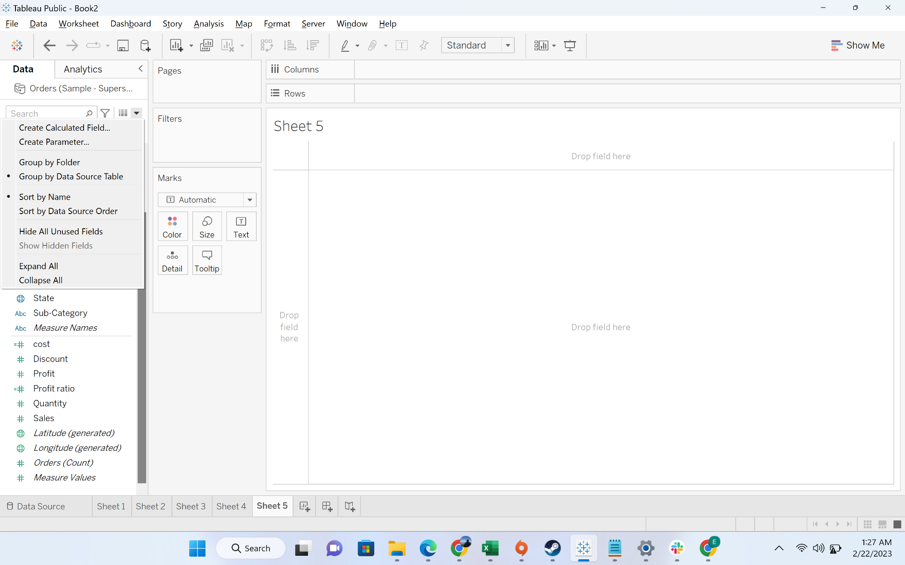

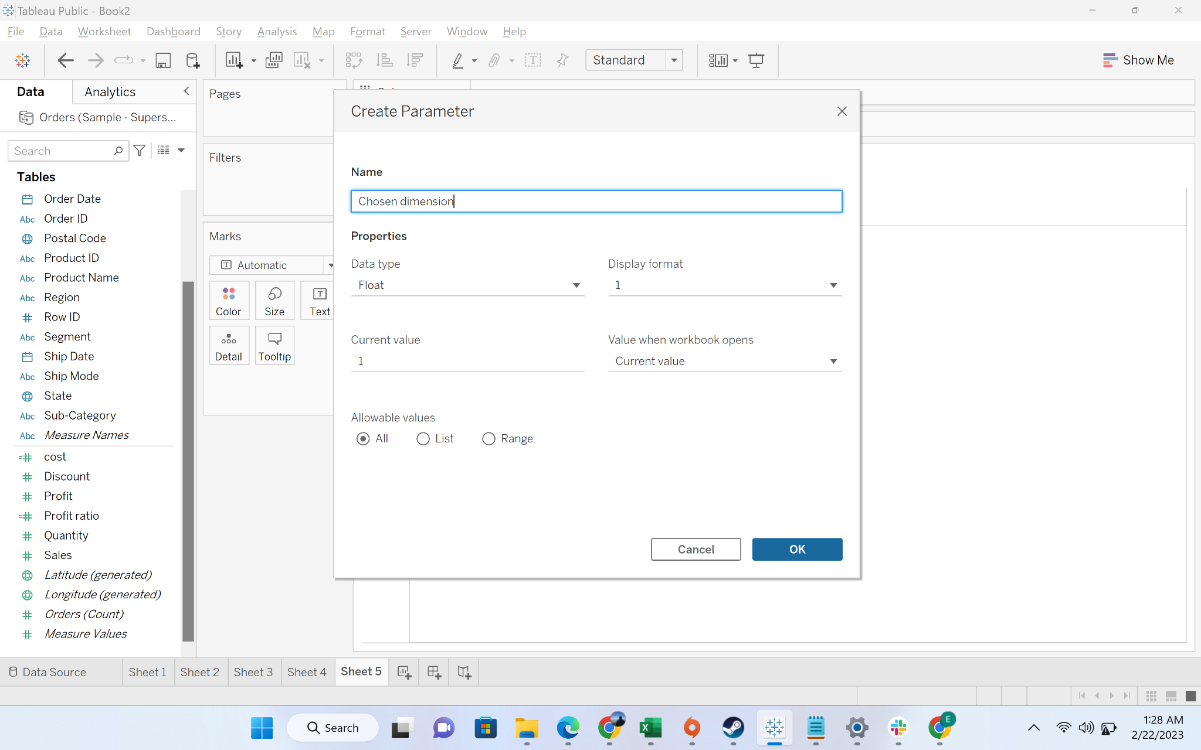

* + Step-2: Change the data type to “String”

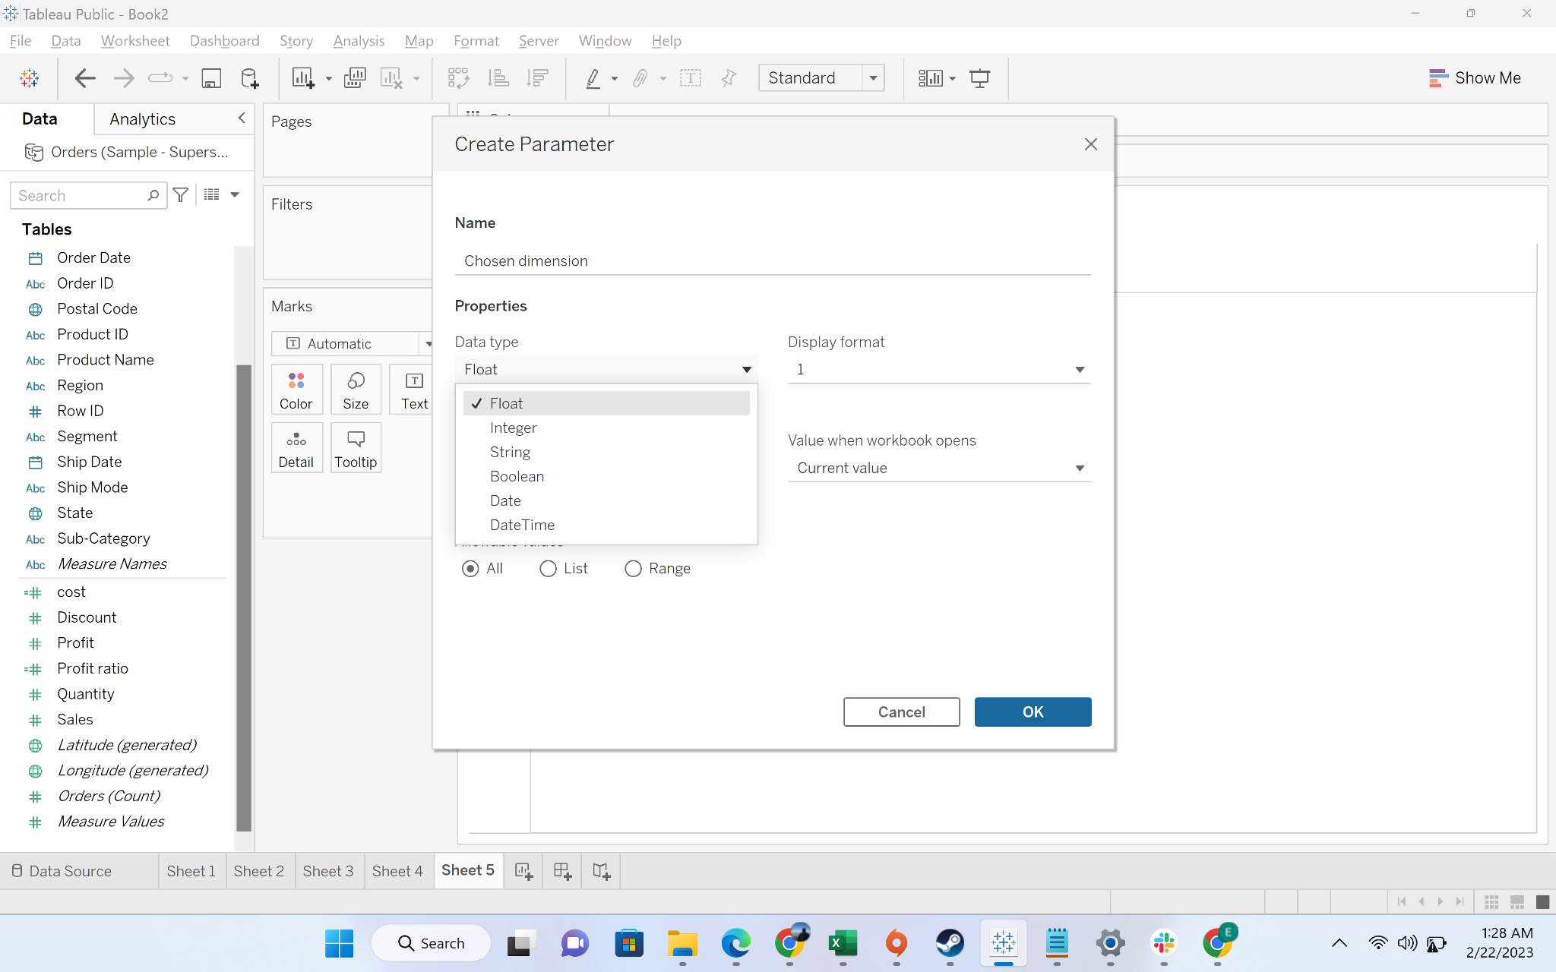

* + Step-3: Change the allowable values to ‘list’

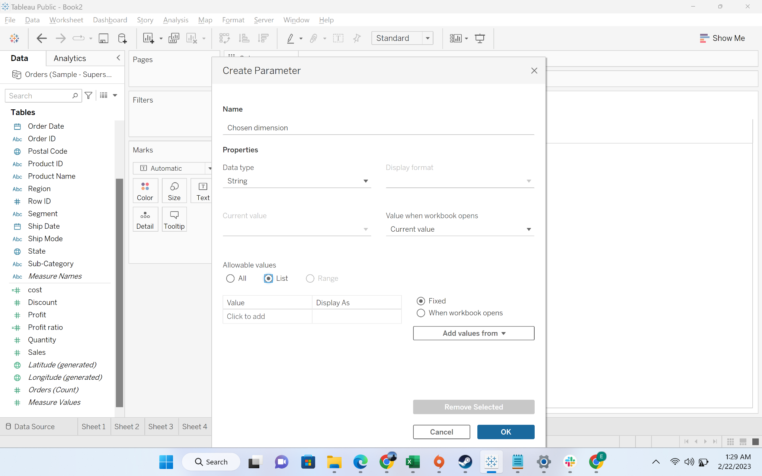

* + Step-4: Add the following values in the list: category, sub-category, state

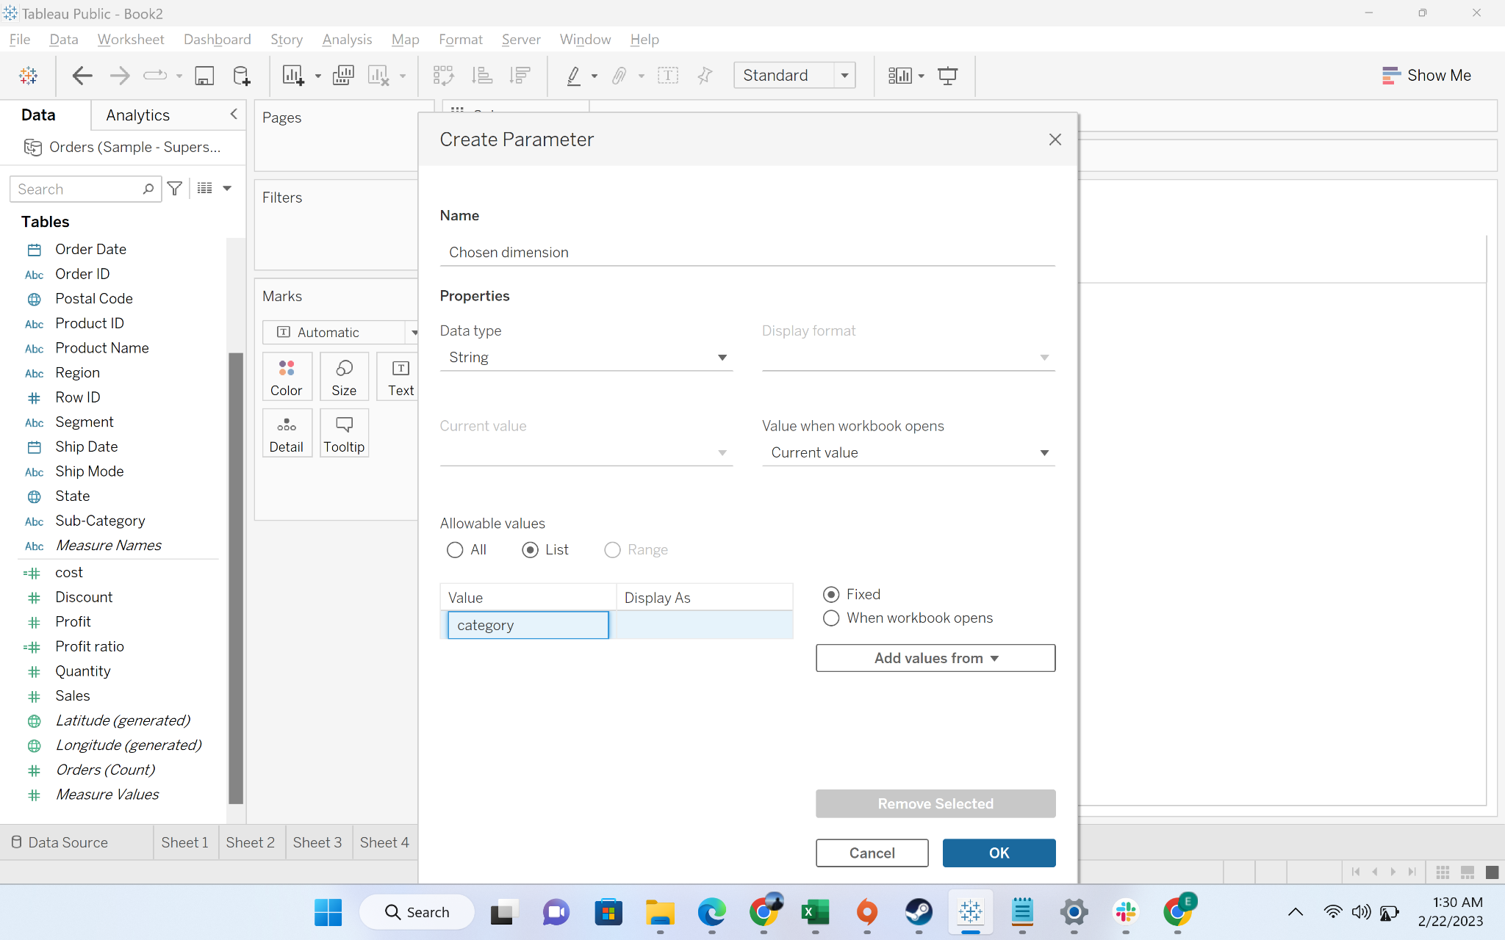

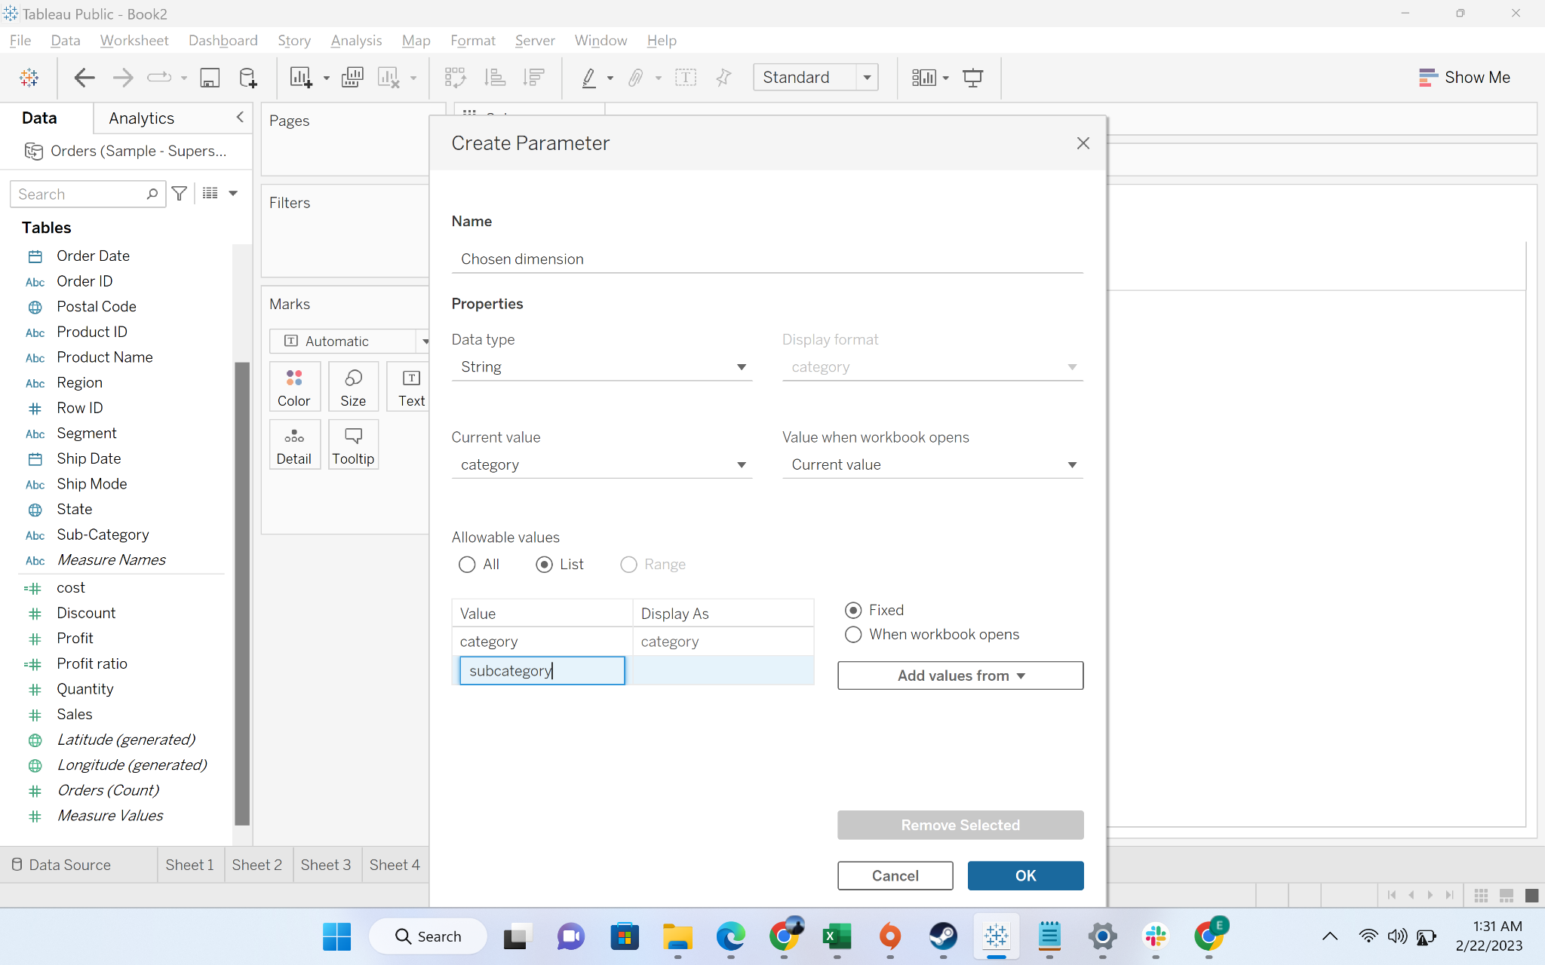

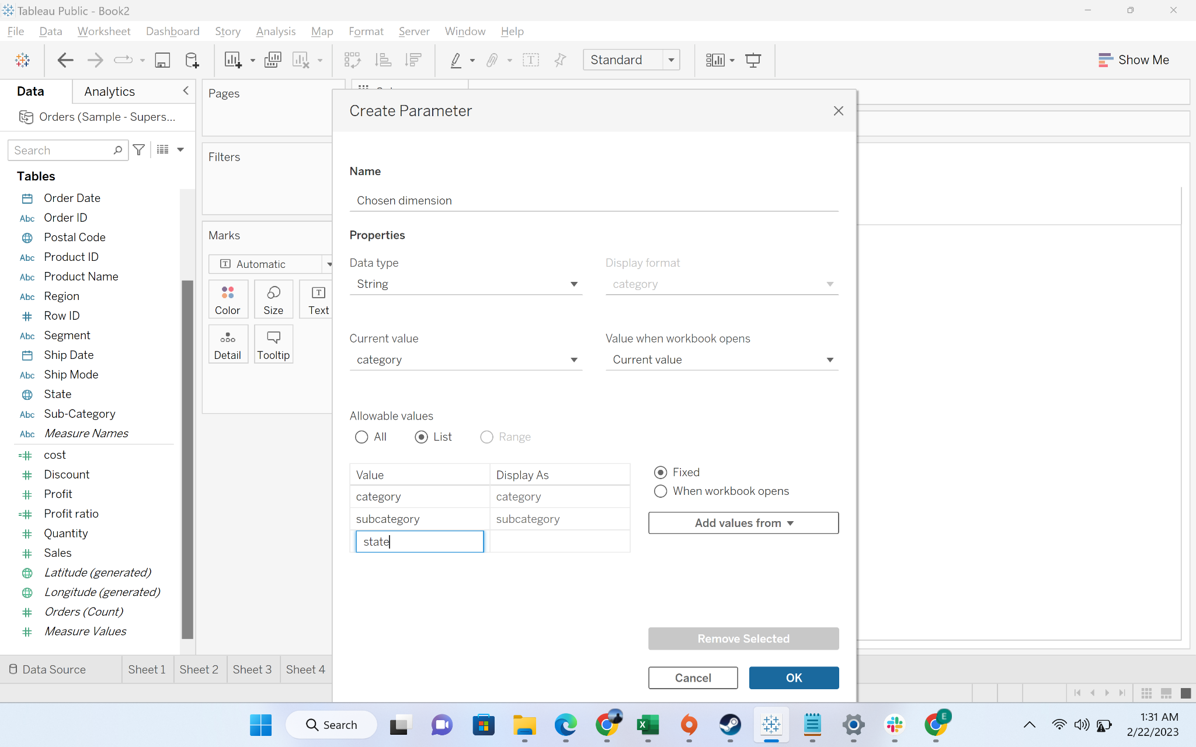

* + Step-5: Show parameter

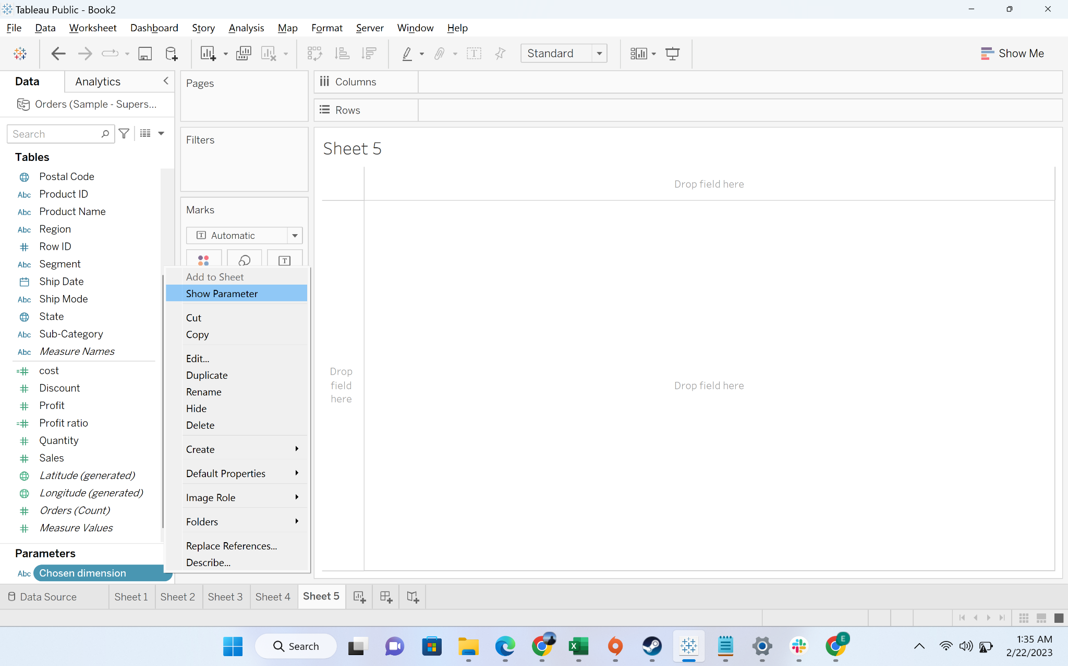

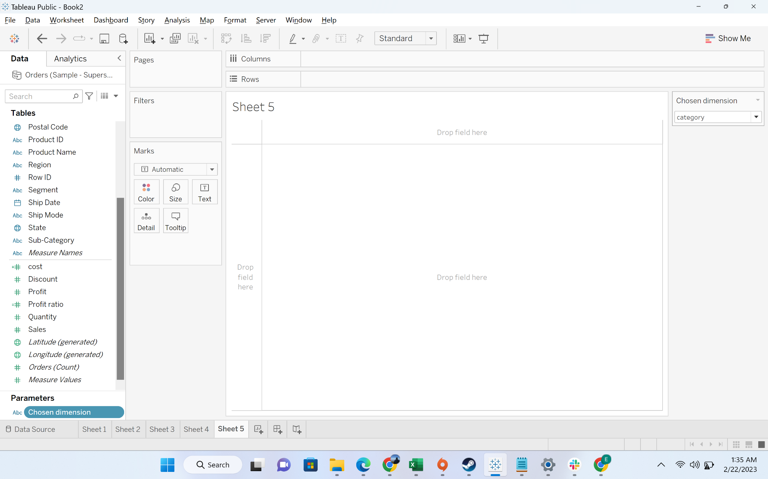

* + Step-6: Now we will create a calculated field called dimension list

**Formula**

CASE [Chosen dimension]

WHEN 'category'

THEN [Category]

WHEN 'subcategory'

THEN [Sub-Category]

WHEN 'state'

THEN [State]

END

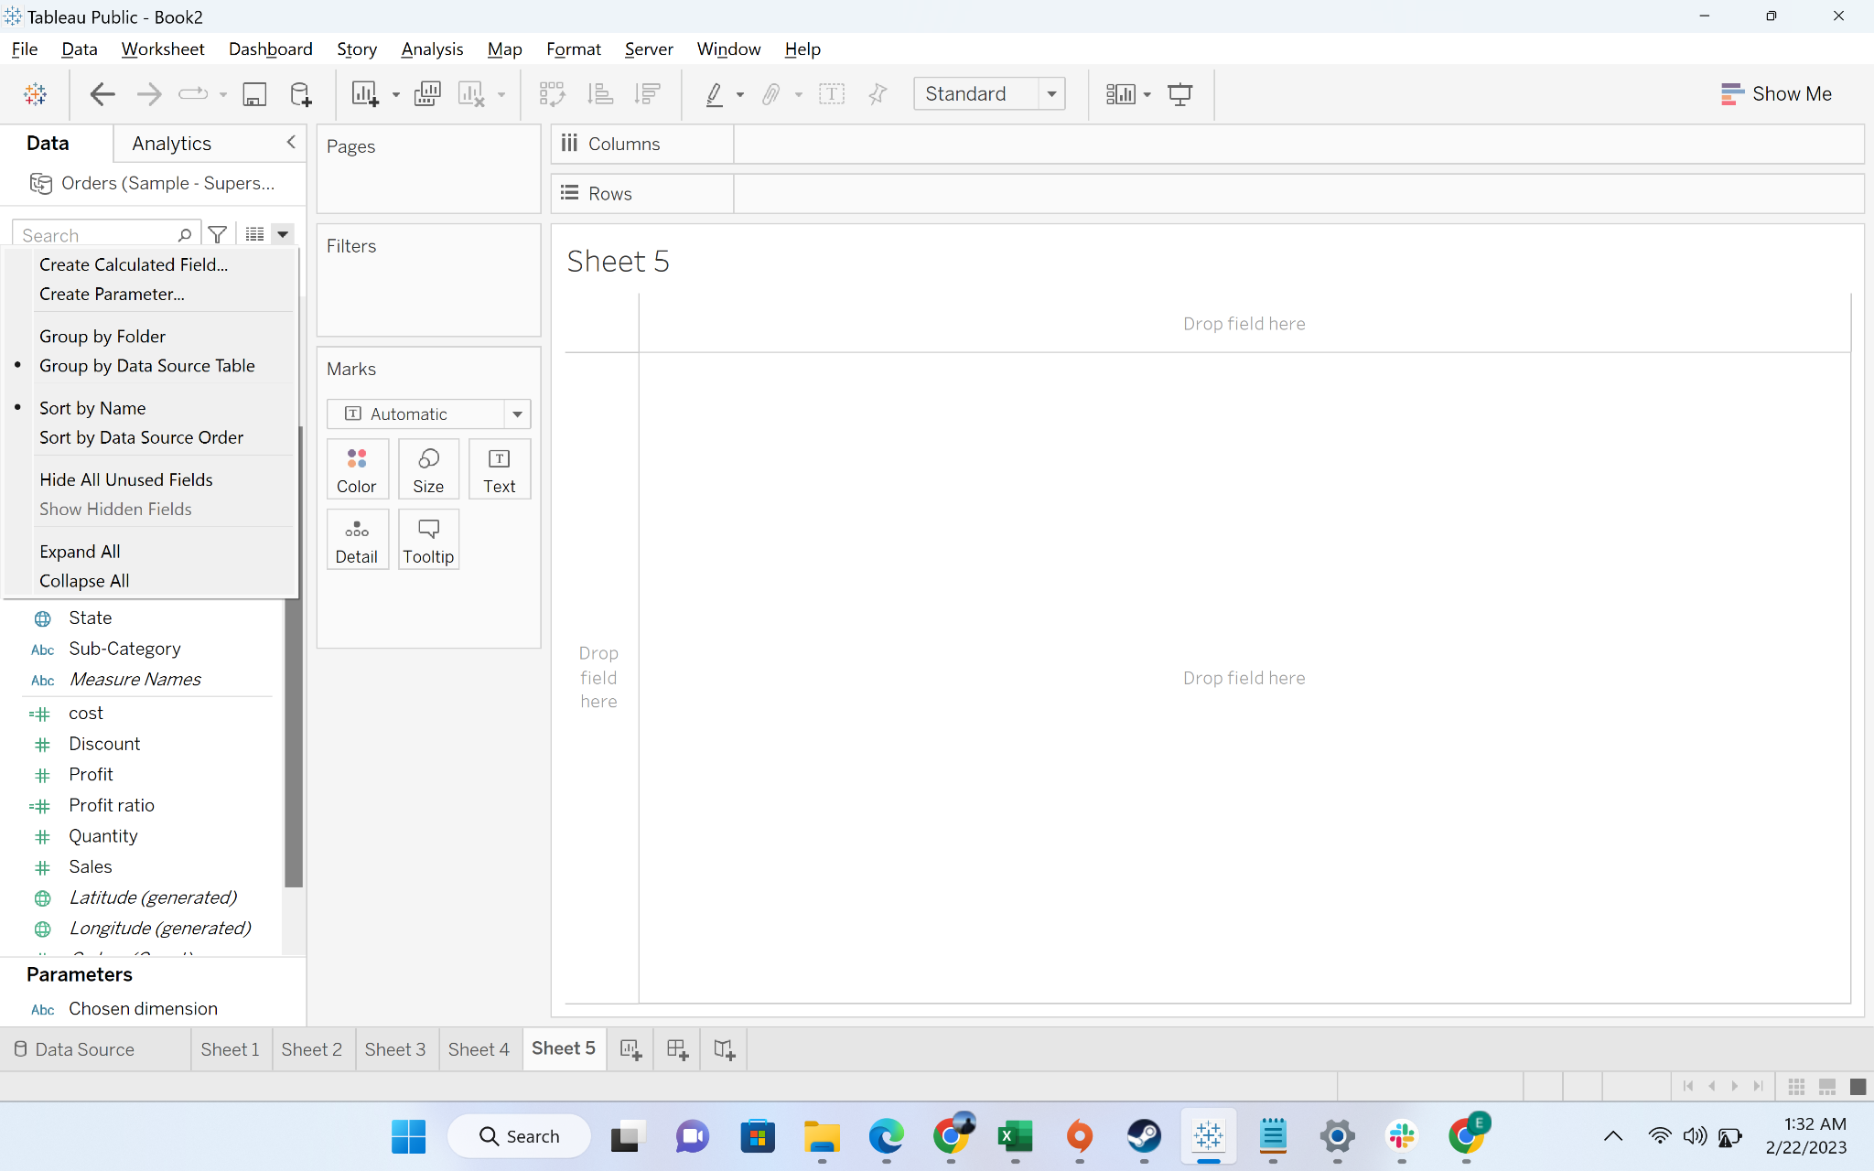

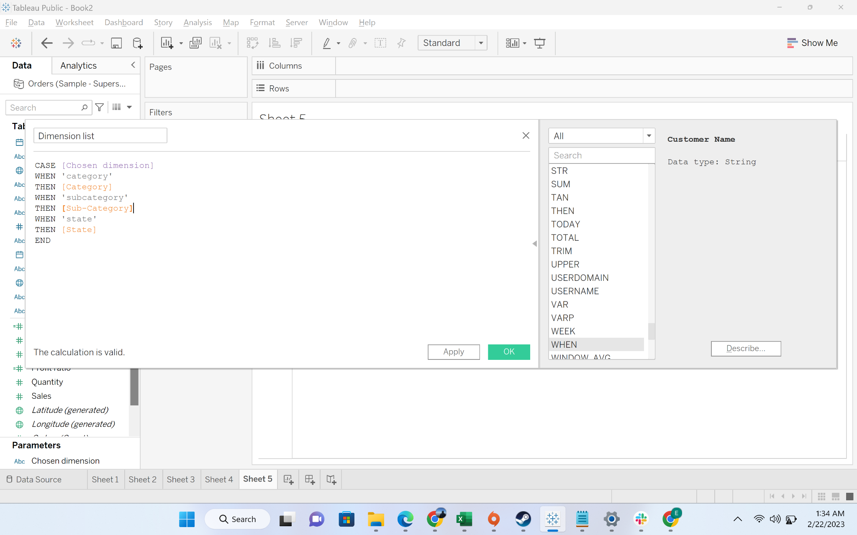

* + Step-7: drag dimension list to rows and sales to columns

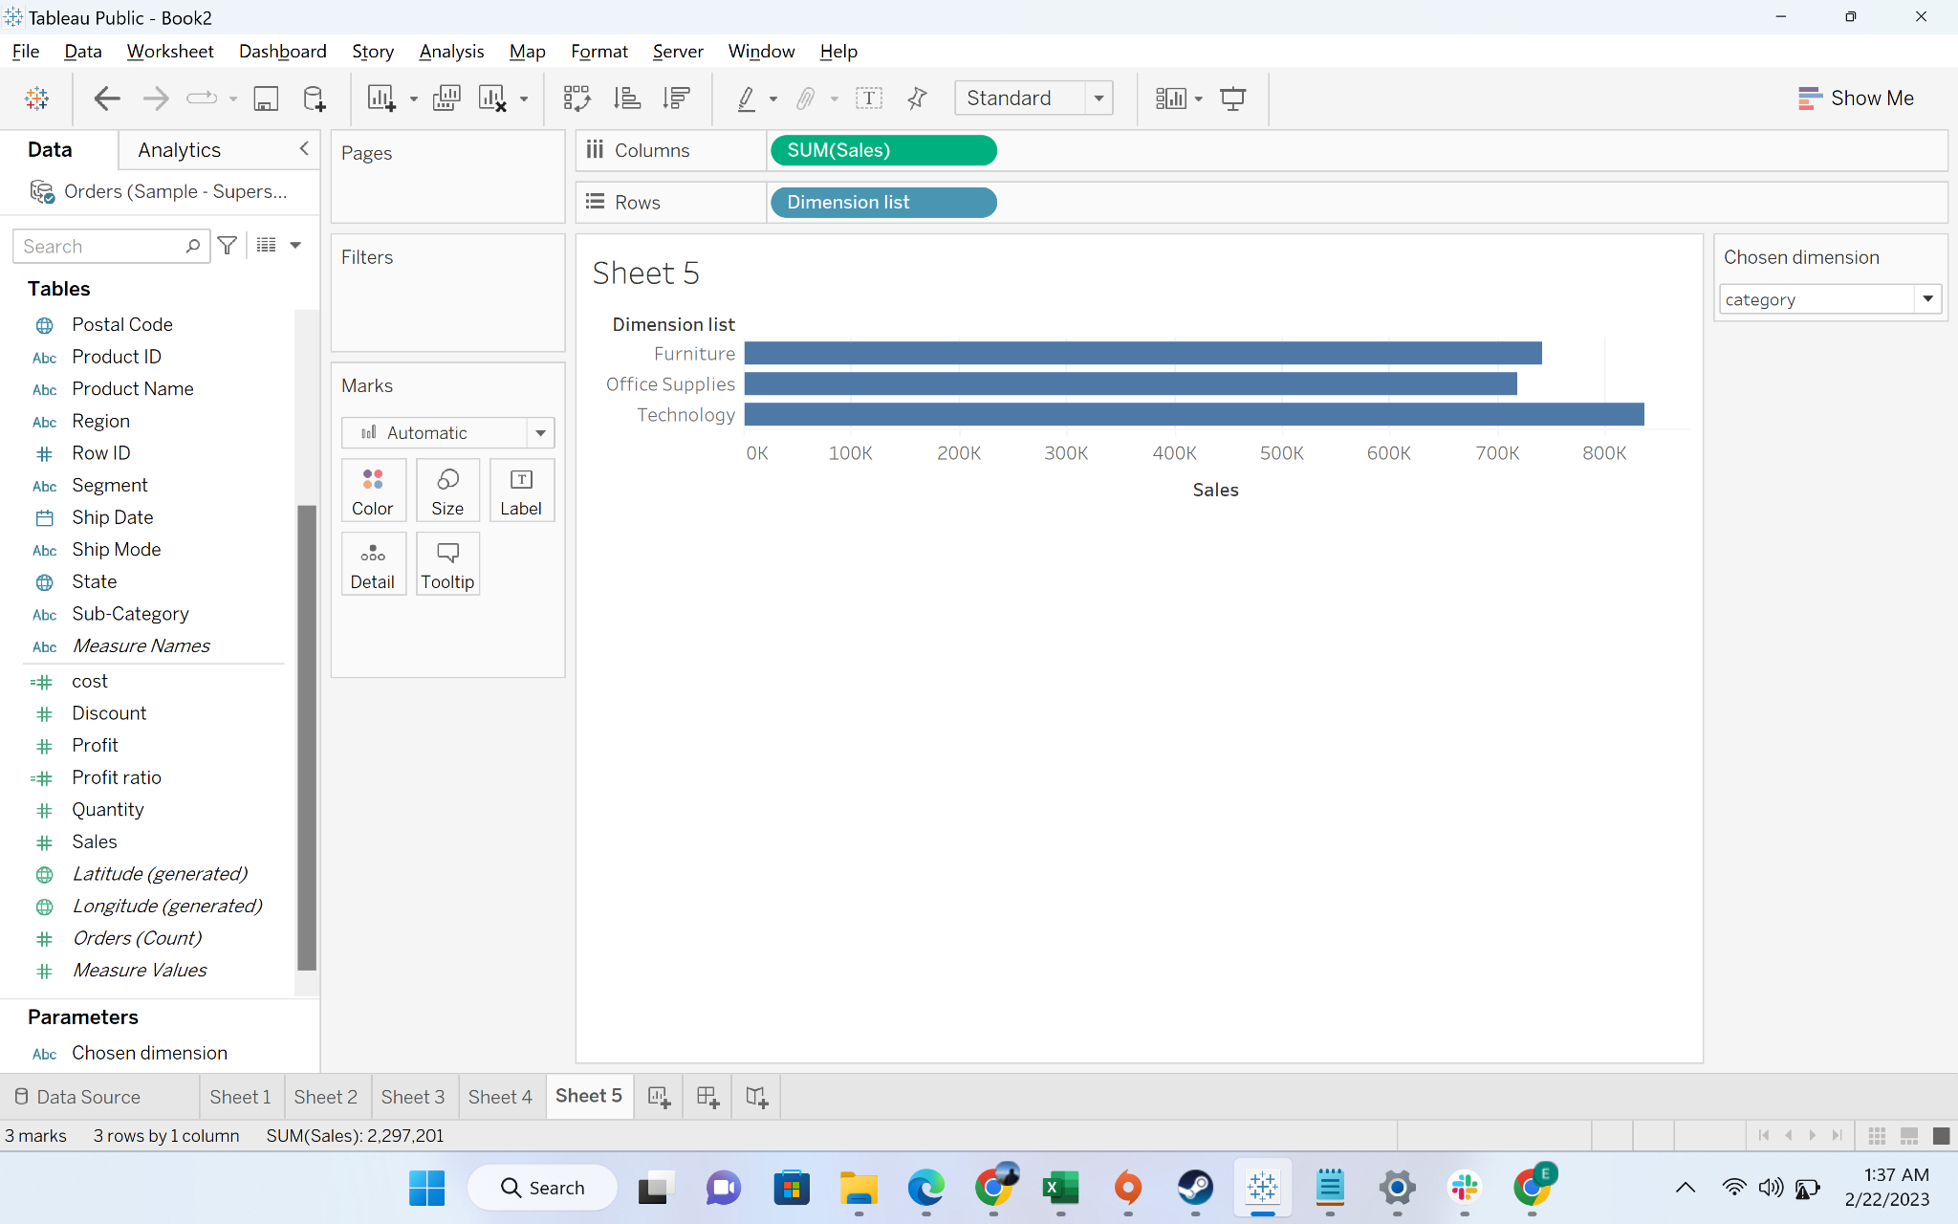

* + Step-8: if we chose subcategory from “Chosen Dimension”

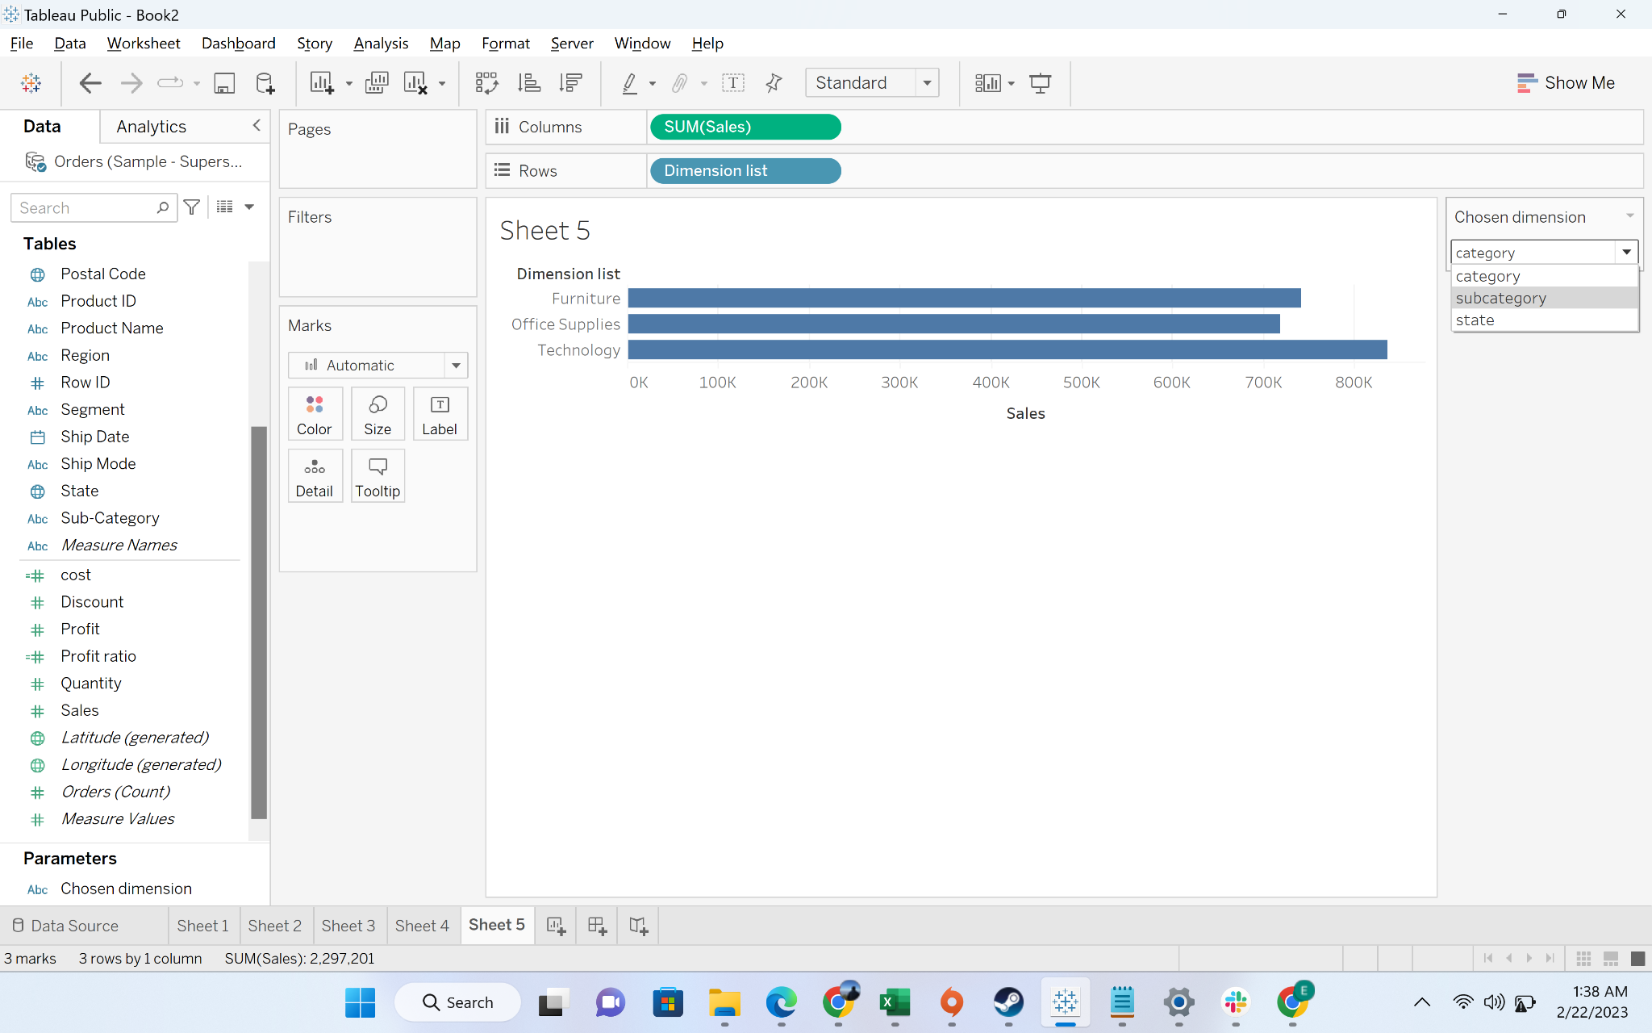

* + Step-9: we will get the sales breakdown by subcategory

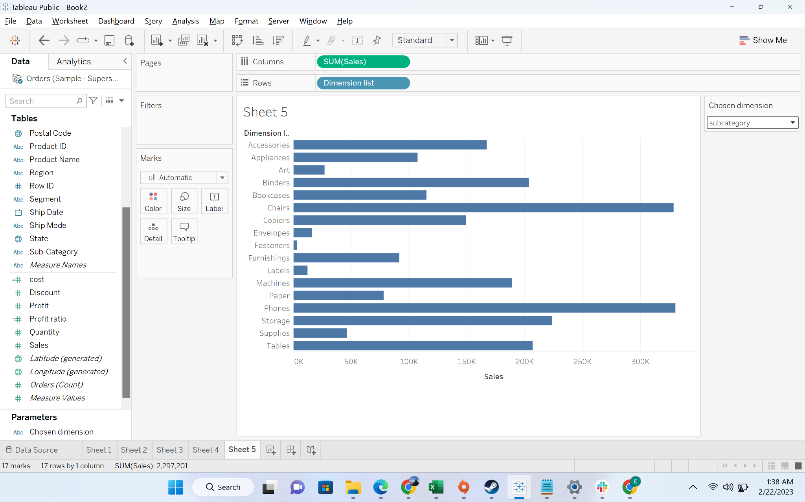

#### 

#### Level of Details (LOD):

Using LOD expressions, a user can compute different levels of aggregations that are not at the level of detail of the visualization.

In Tableau, we have 3 types of Level of Details expressions. These are **“INCLUDE”, “EXCLUDE” and “FIXED”.**

The following is a detailed explanation of each of the LOD expression with examples:

* INCLUDE

As the name suggests, “INCLUDE” level of detail expression compute aggregations considering dimensions which are specified in the calculation and also take into consideration those dimensions which are present in the view.

* EXCLUDE

“EXCLUDE” level of detail expression is used to omit specific dimensions from the aggregations. Using “EXCLUDE”, the user can omit the lower level granularity dimension which is present in the view and can directly calculate the value at higher granularity level.

* FIXED

“FIXED” level of detail expression aggregates the value only at the dimensions which are specified by the user in the calculation. “FIXED” expression does not take into consideration those dimensions in the view.

#### Business Problem-2: Create an executive summary report to show following fields:

**Sub-category, category, sales per sub-category, average sales per customer per subcategory, percentage of sales contributed per subcategory at category level, percentage of sales contributed per subcategory at country level.**

Solution:

* Business context: For sales review meeting, sales organization want to understand the drivers of revenue per category and country level, and decide the growth strategy
* Steps:
  + Drag category, subcategory to rows, and sales to label. So fat we have generated three columns we want for our report

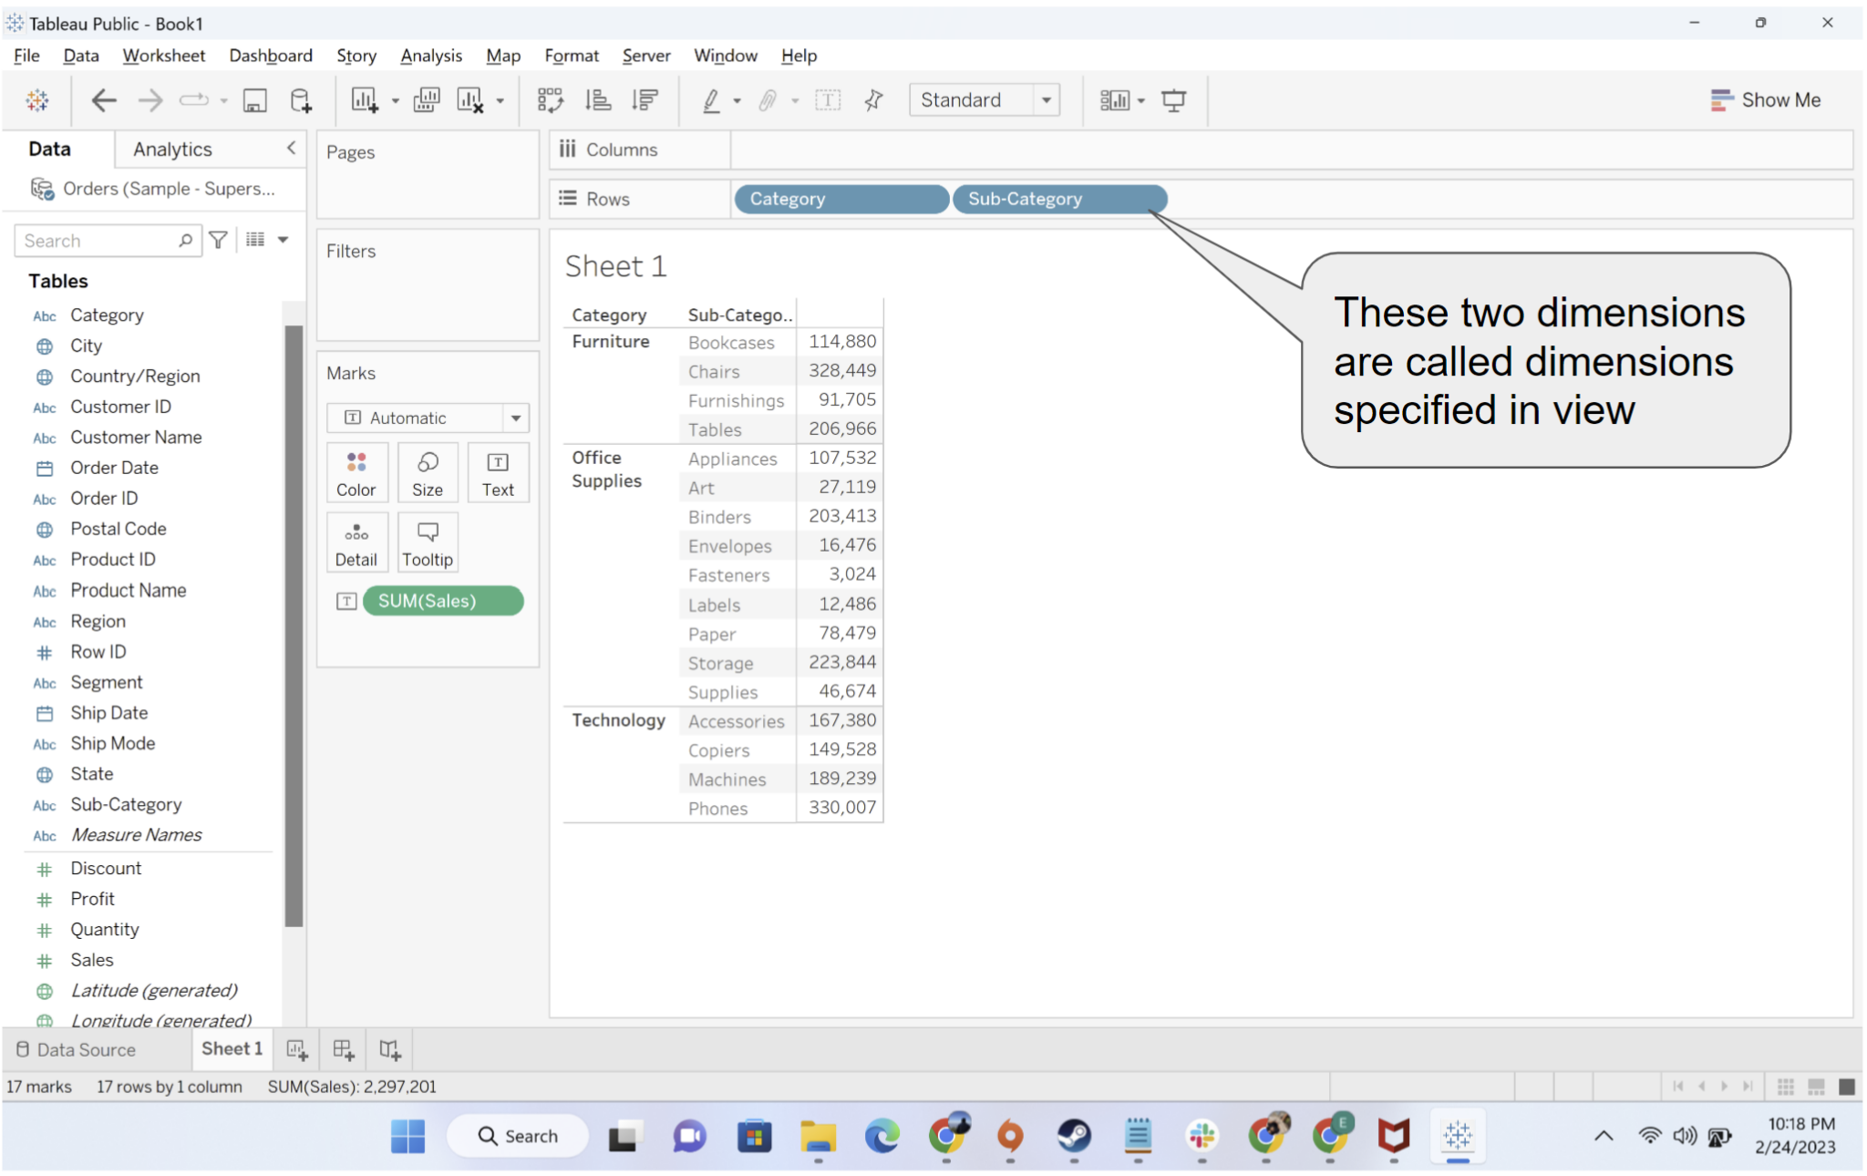

* + Now we will learn about generating the fourth column, average sales per customer per subcategory. average sales per customer per subcategory, we need to first calculate sales per customer per subcategory, and then take the average of it.
  + Here, you can see customer id is not part of the dimensions in the view and we need to include a lower granularity dimension, we will use “include” LOD.
  + We will now create a calculated field sales per customer

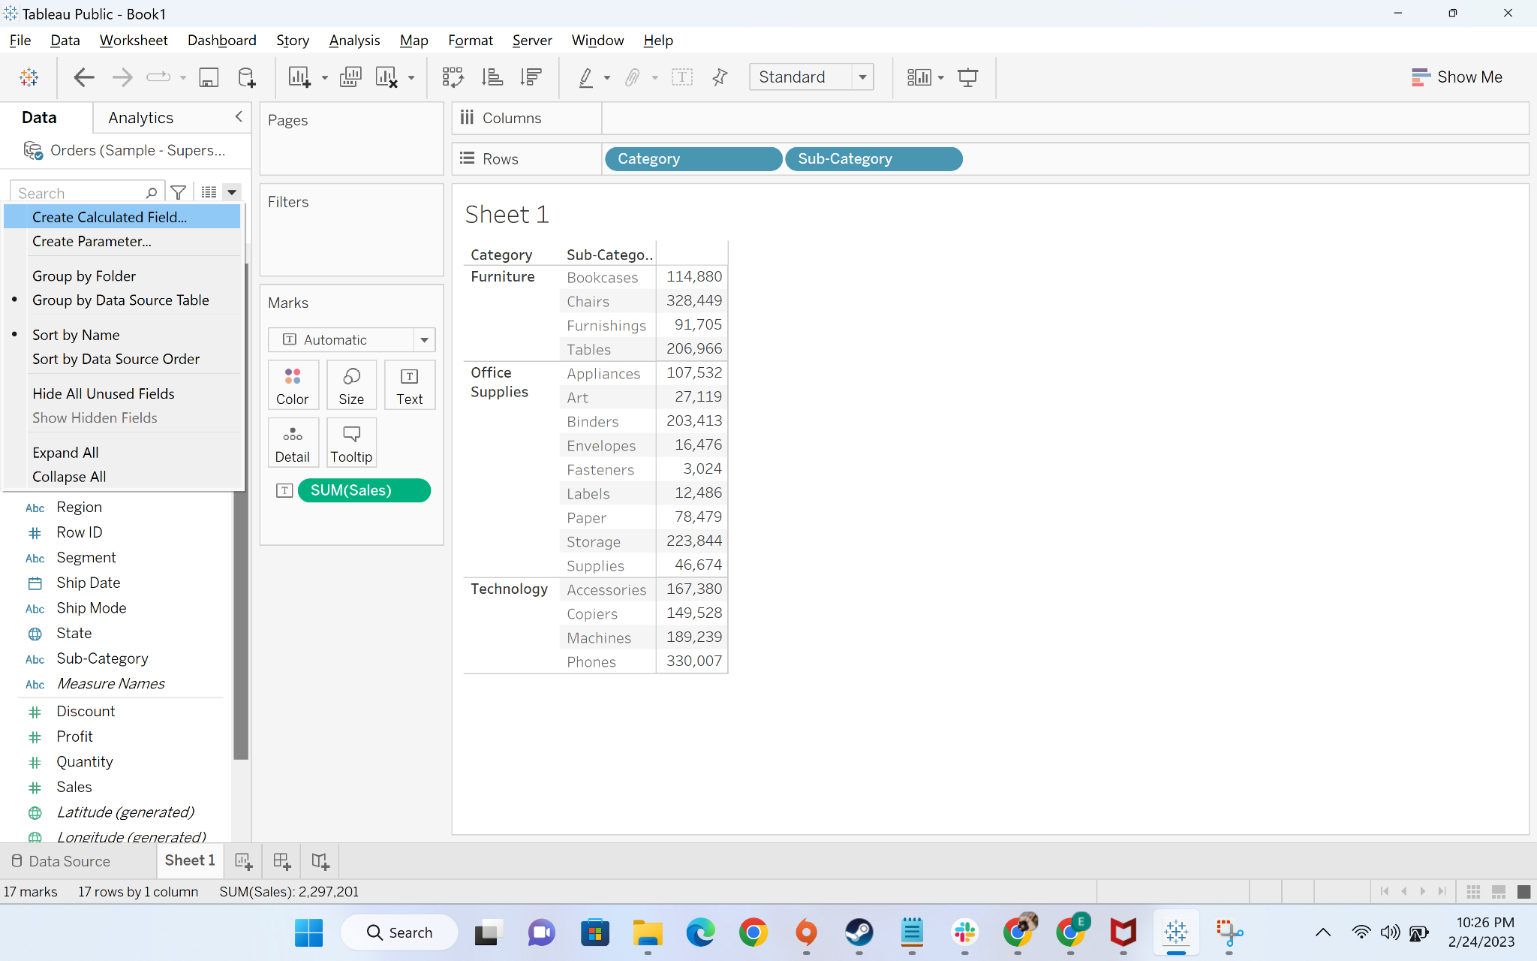

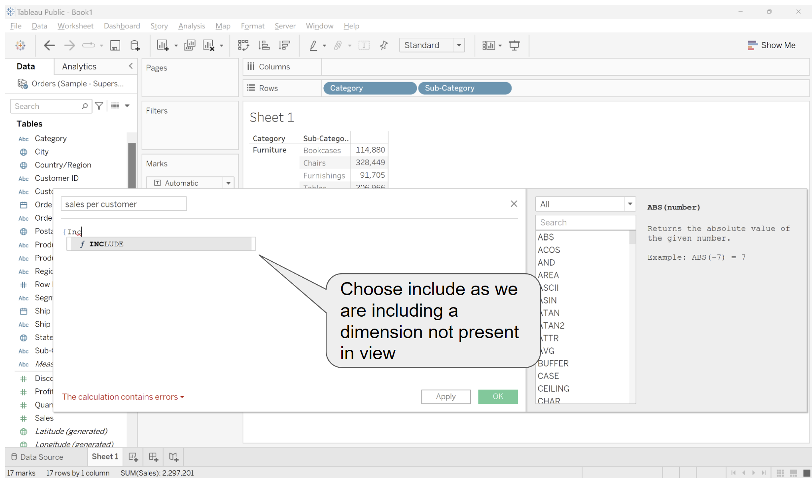

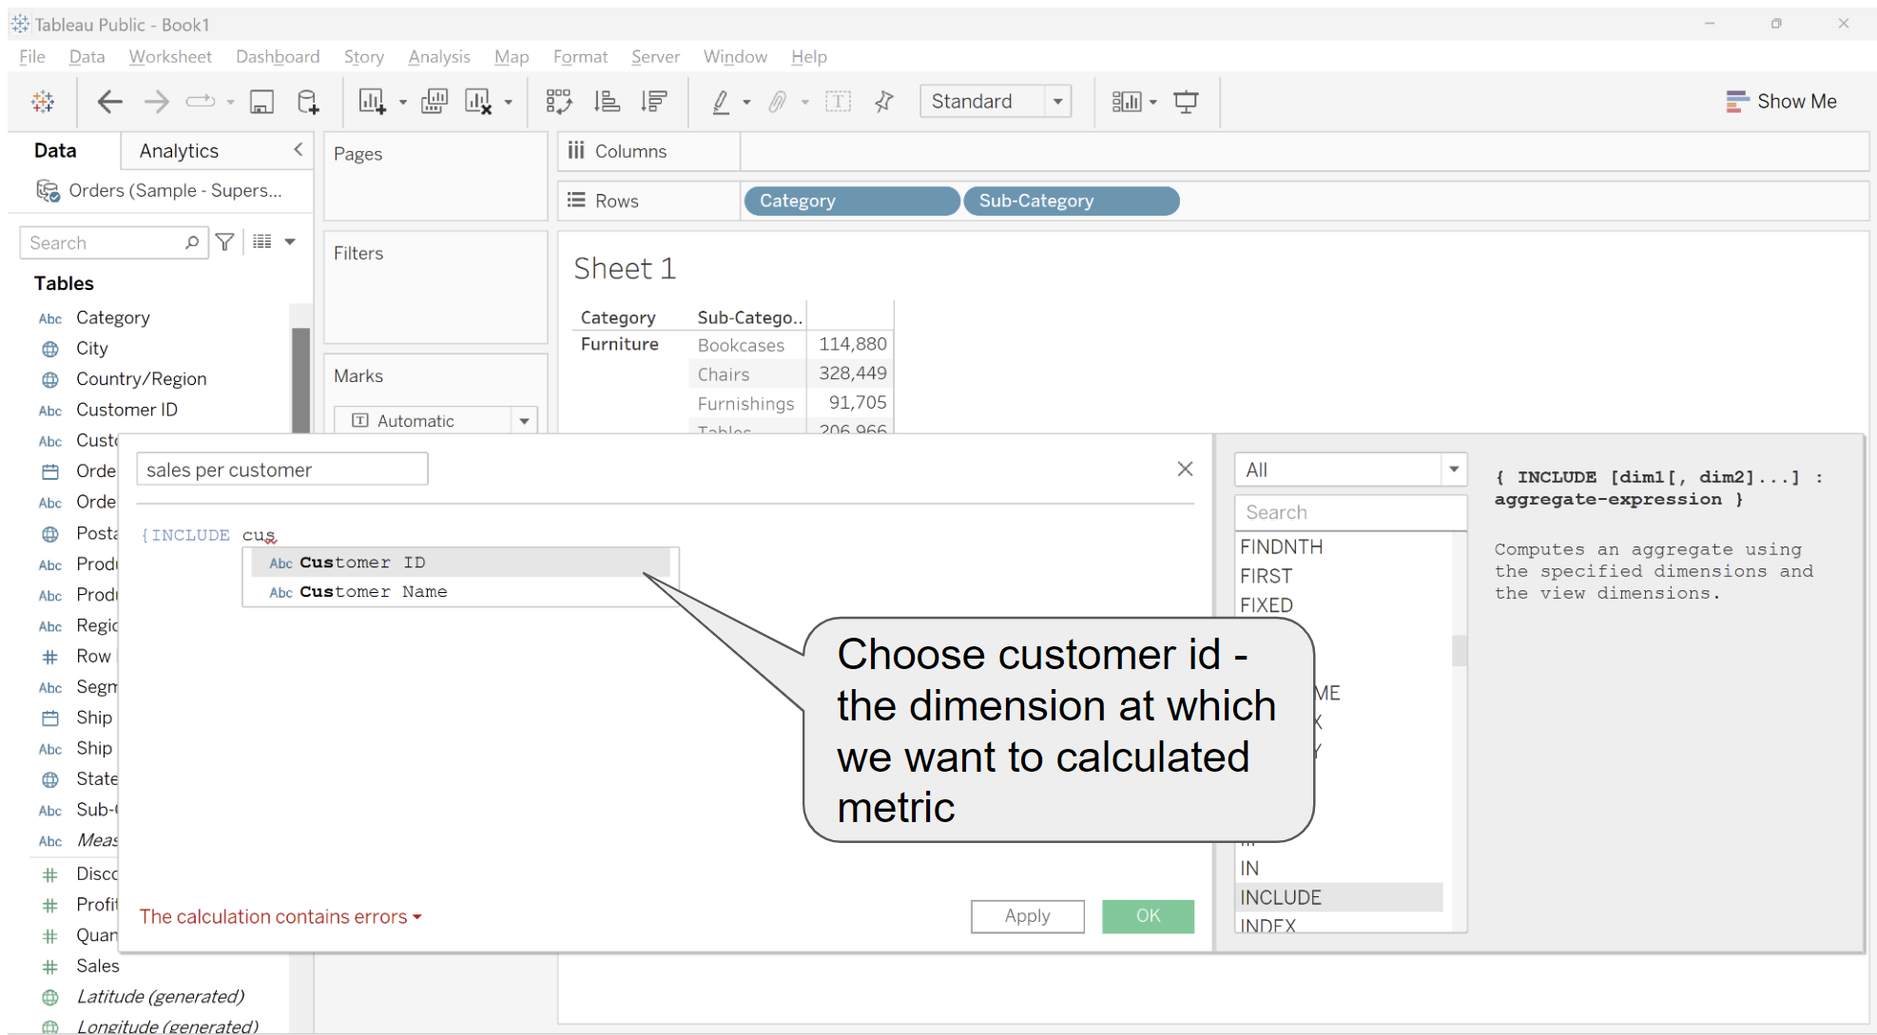

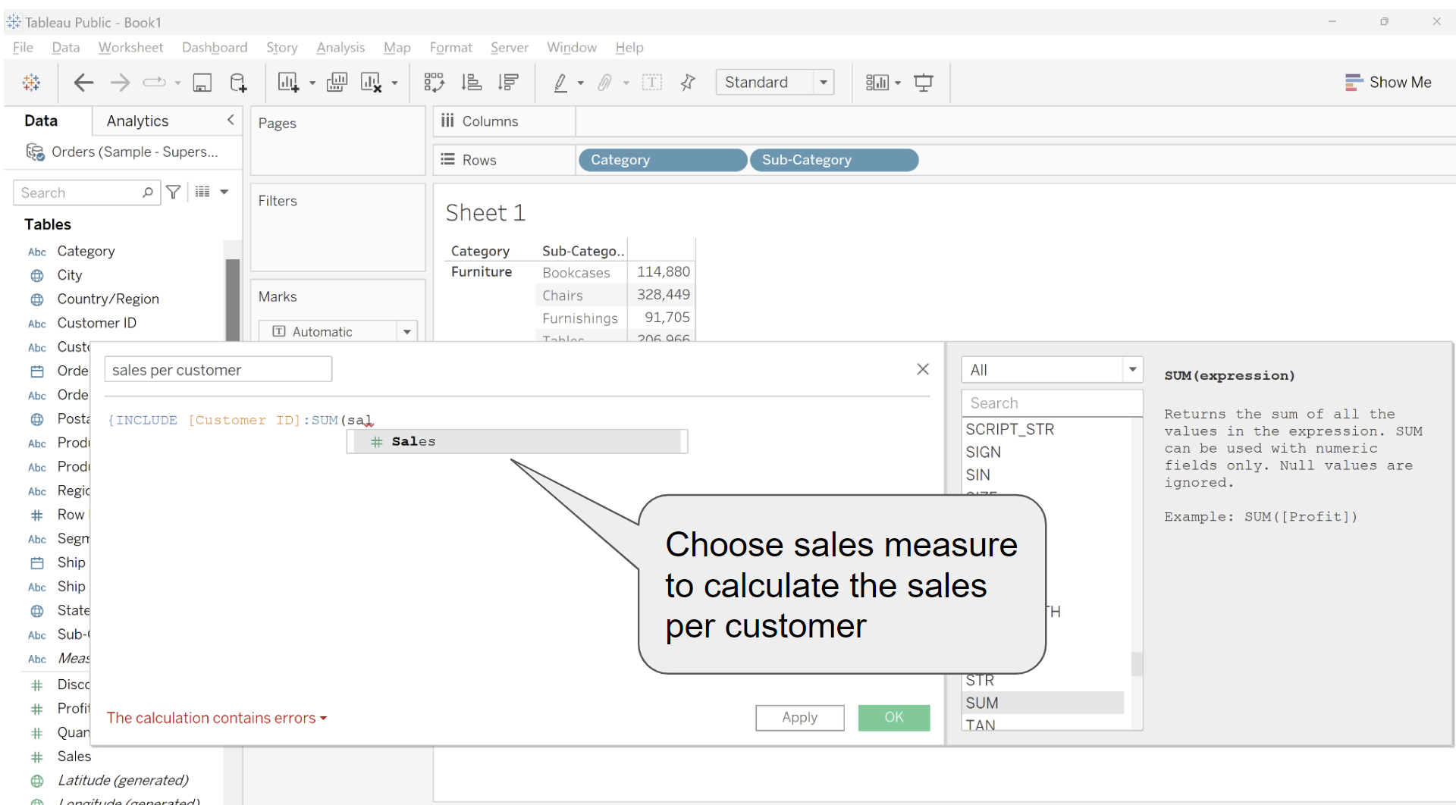

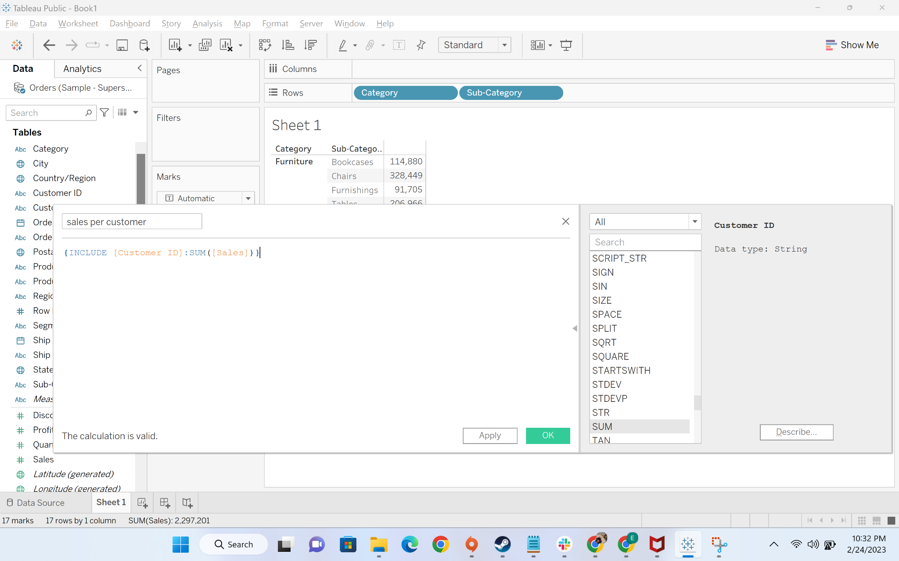

* + Drag the sales per customer to labels and change it from sum to average

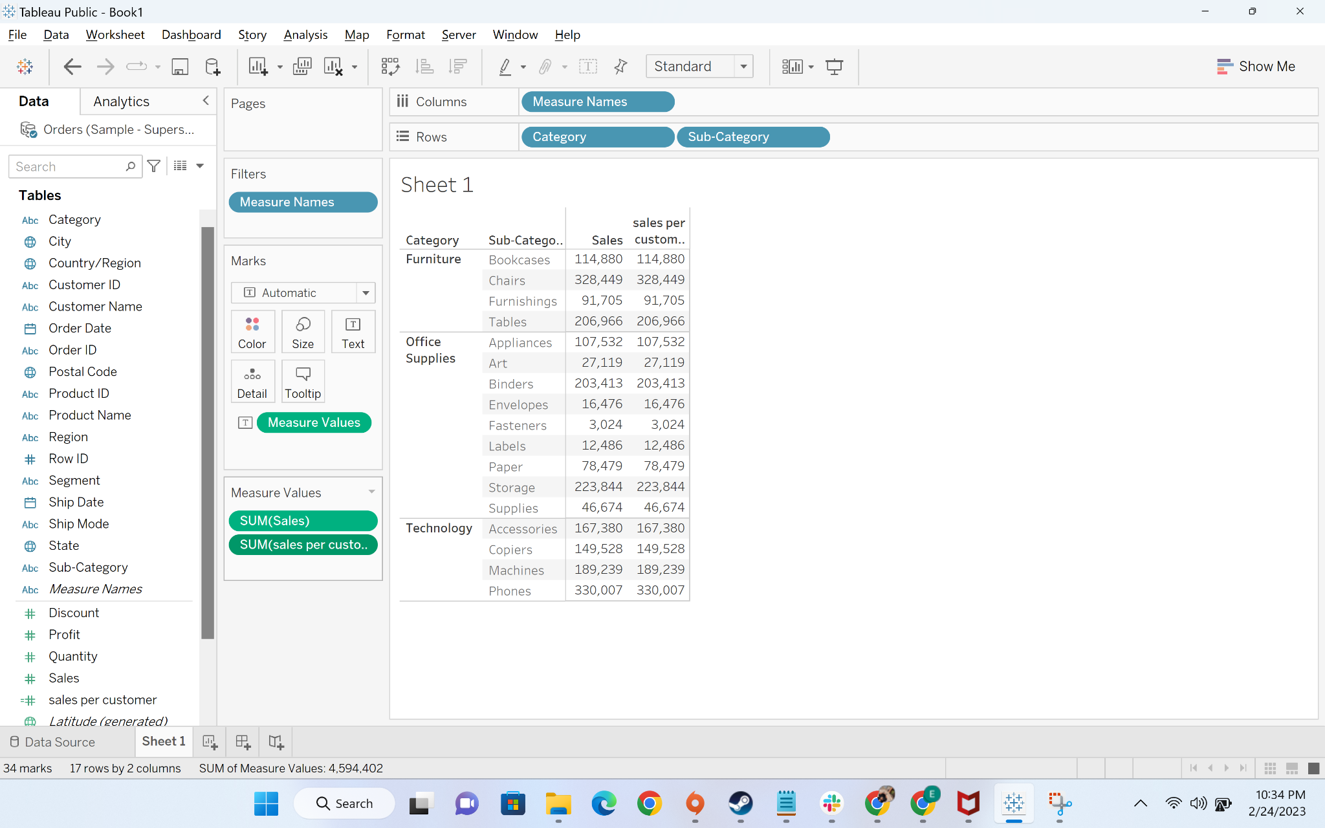

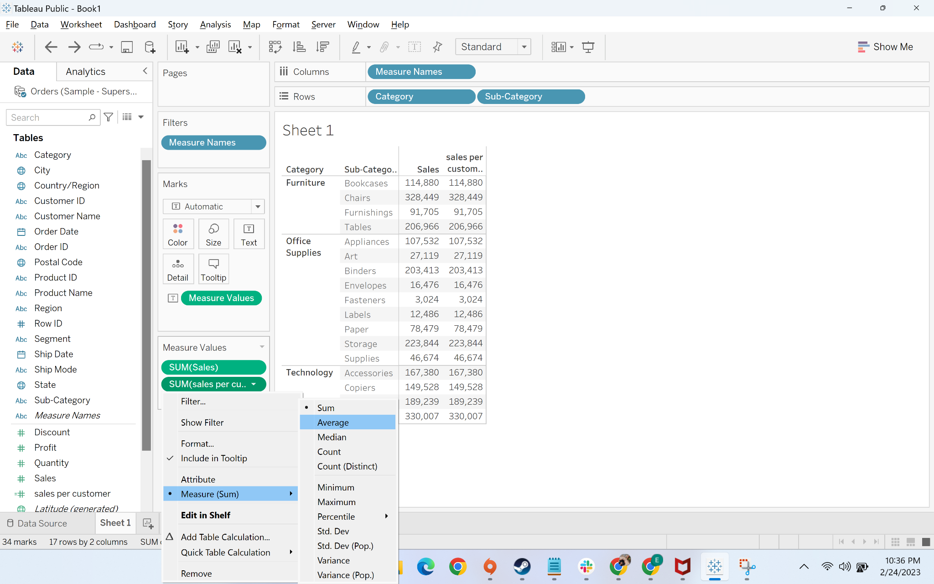

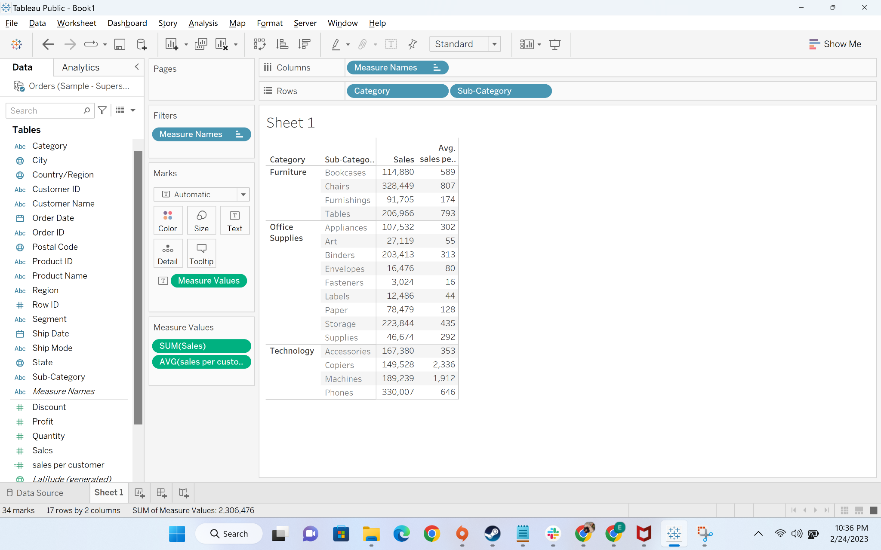

* + Now we will move to the next part of the analysis where we have to find the percentage **of sales contributed per subcategory at category level.**  This step will be divided into two parts
    - First, we will create a column to calculate sales per category. To calculate the sales per category, we need to exclude the subcategory which is visible in view

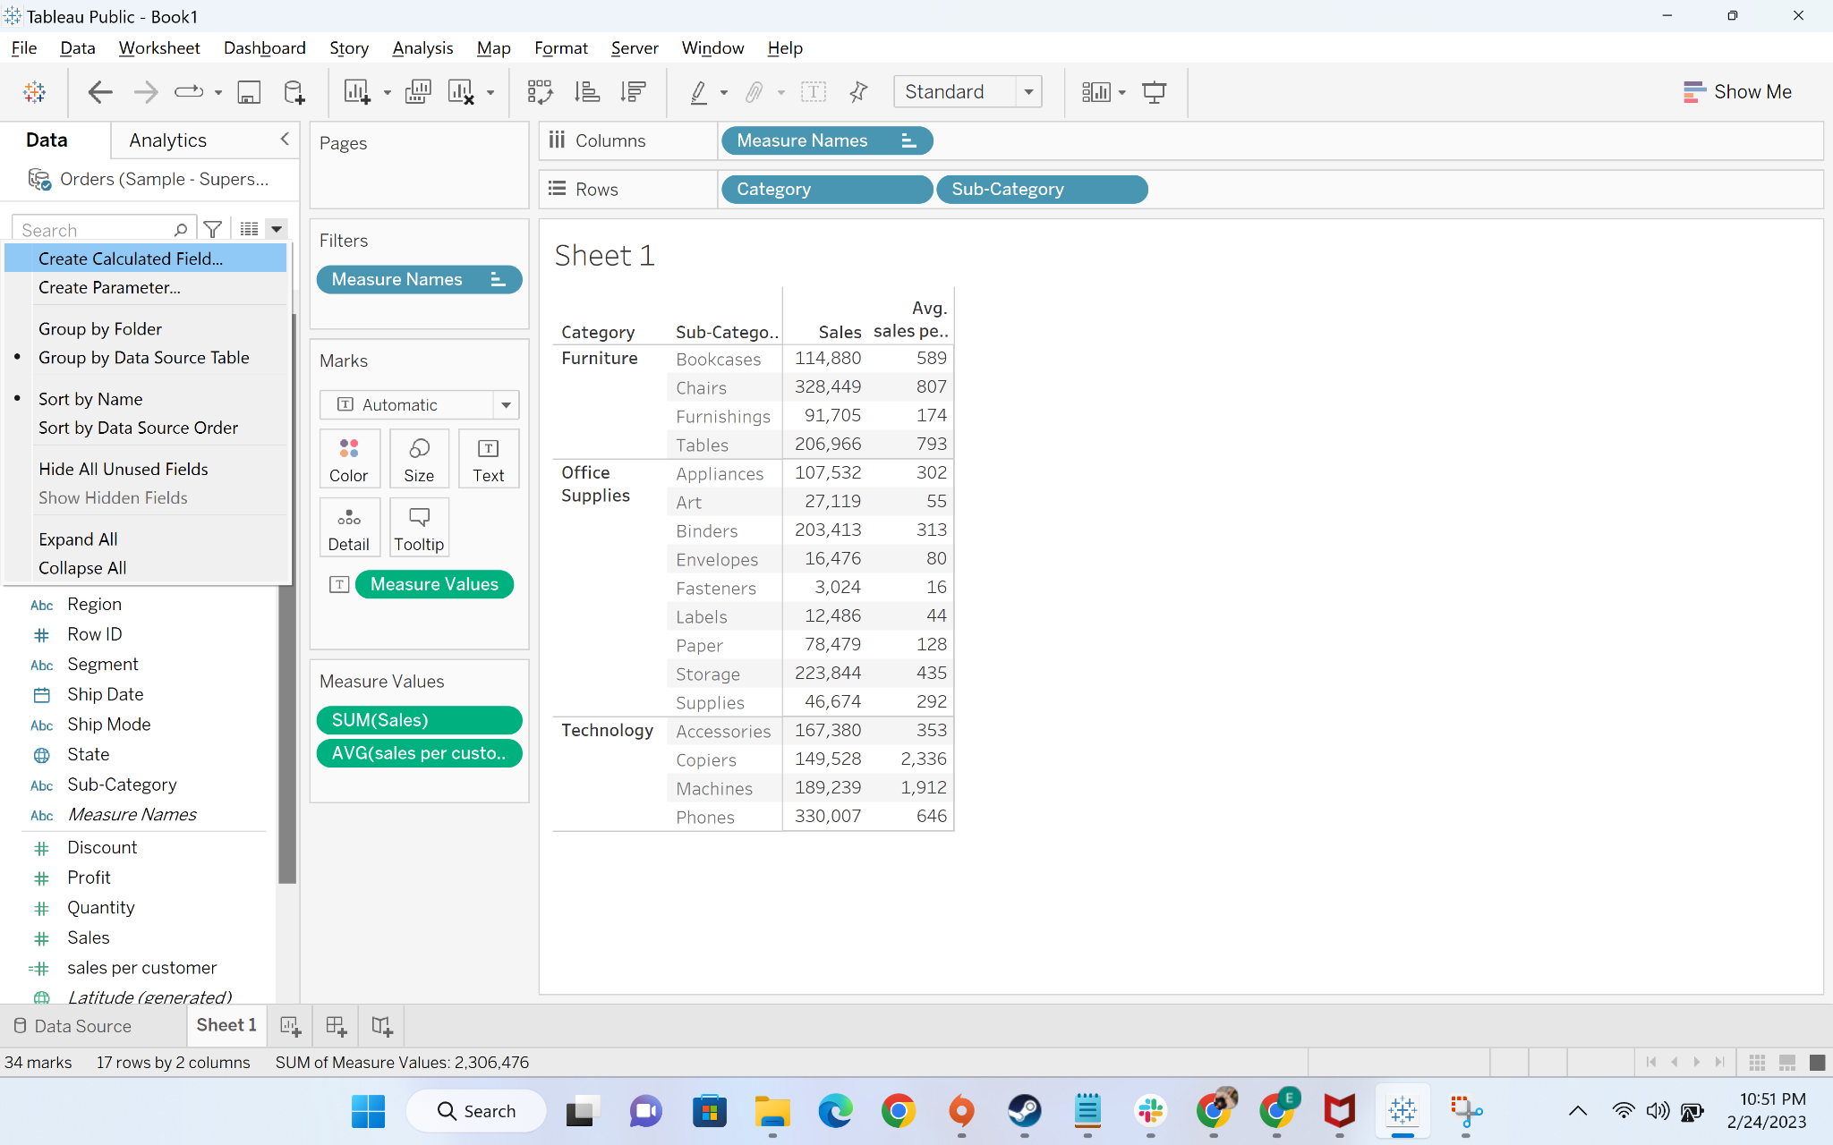

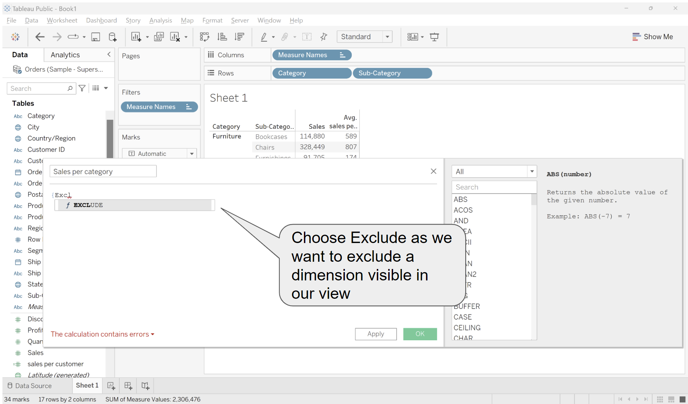

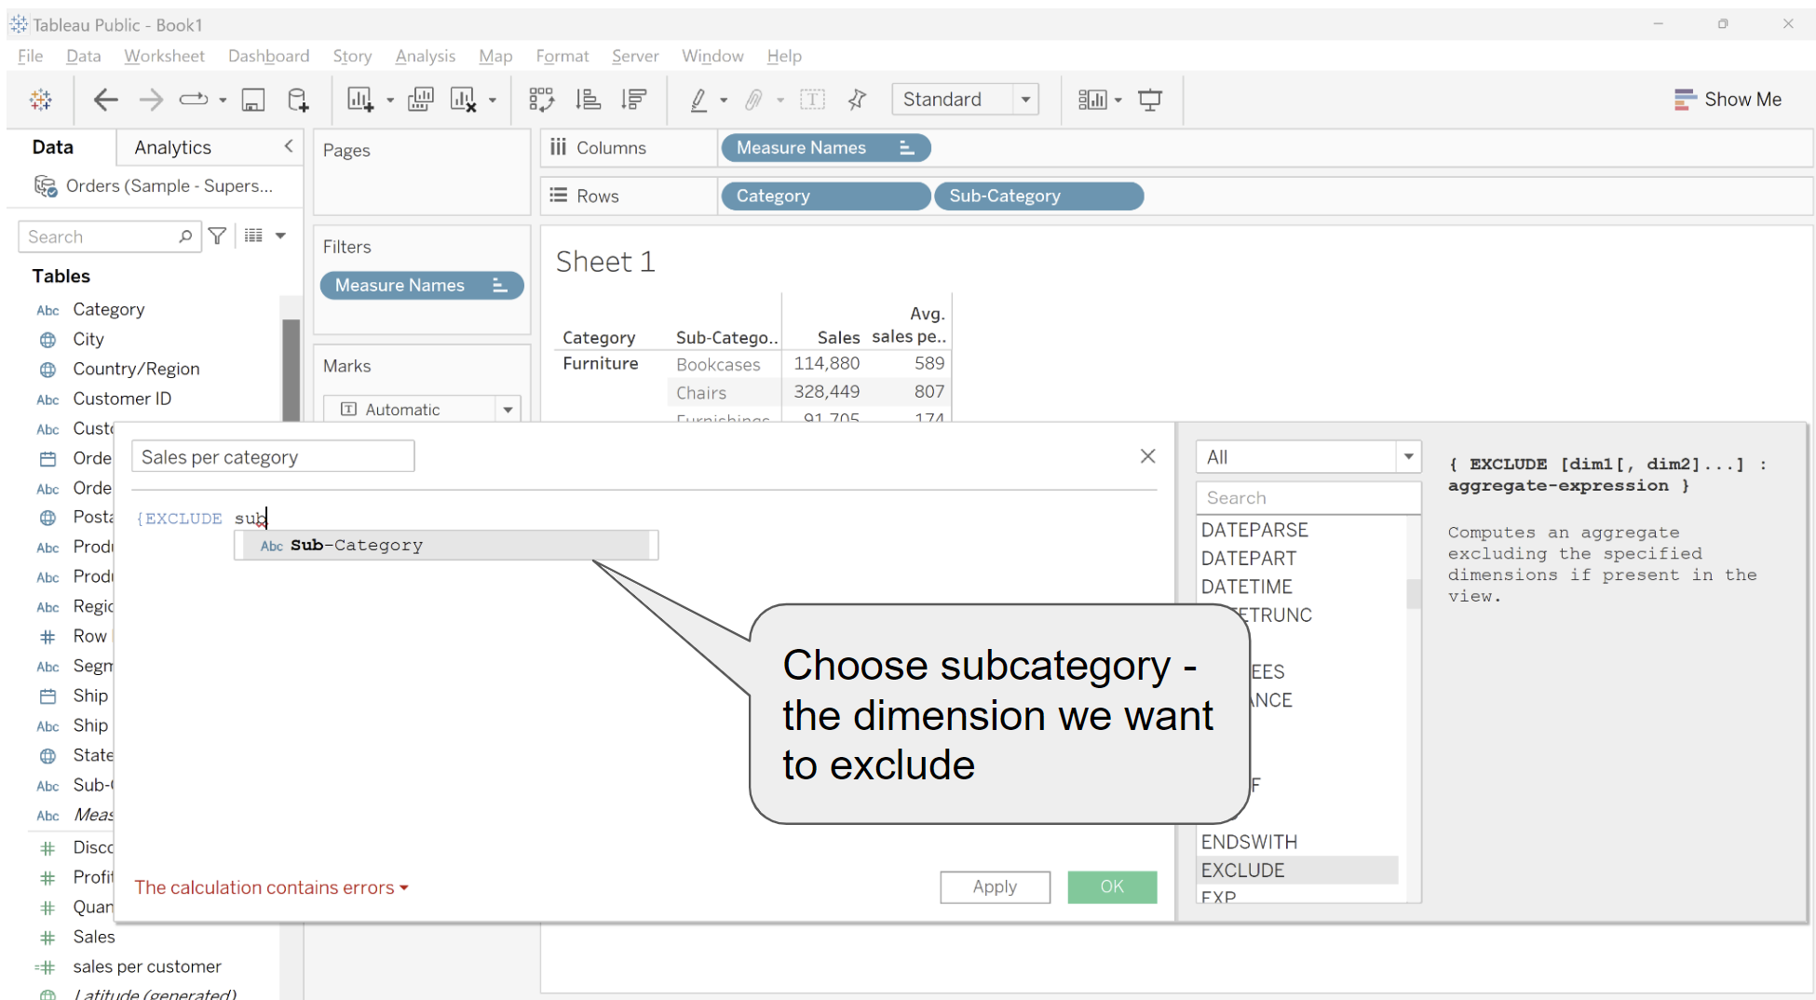  
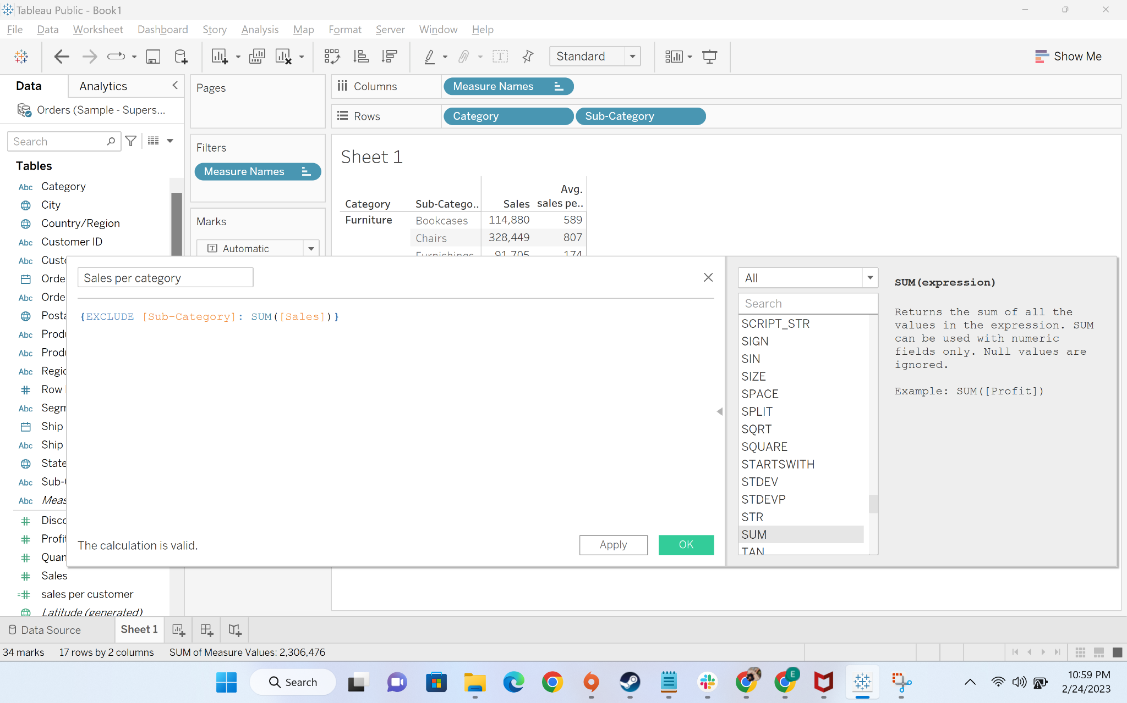

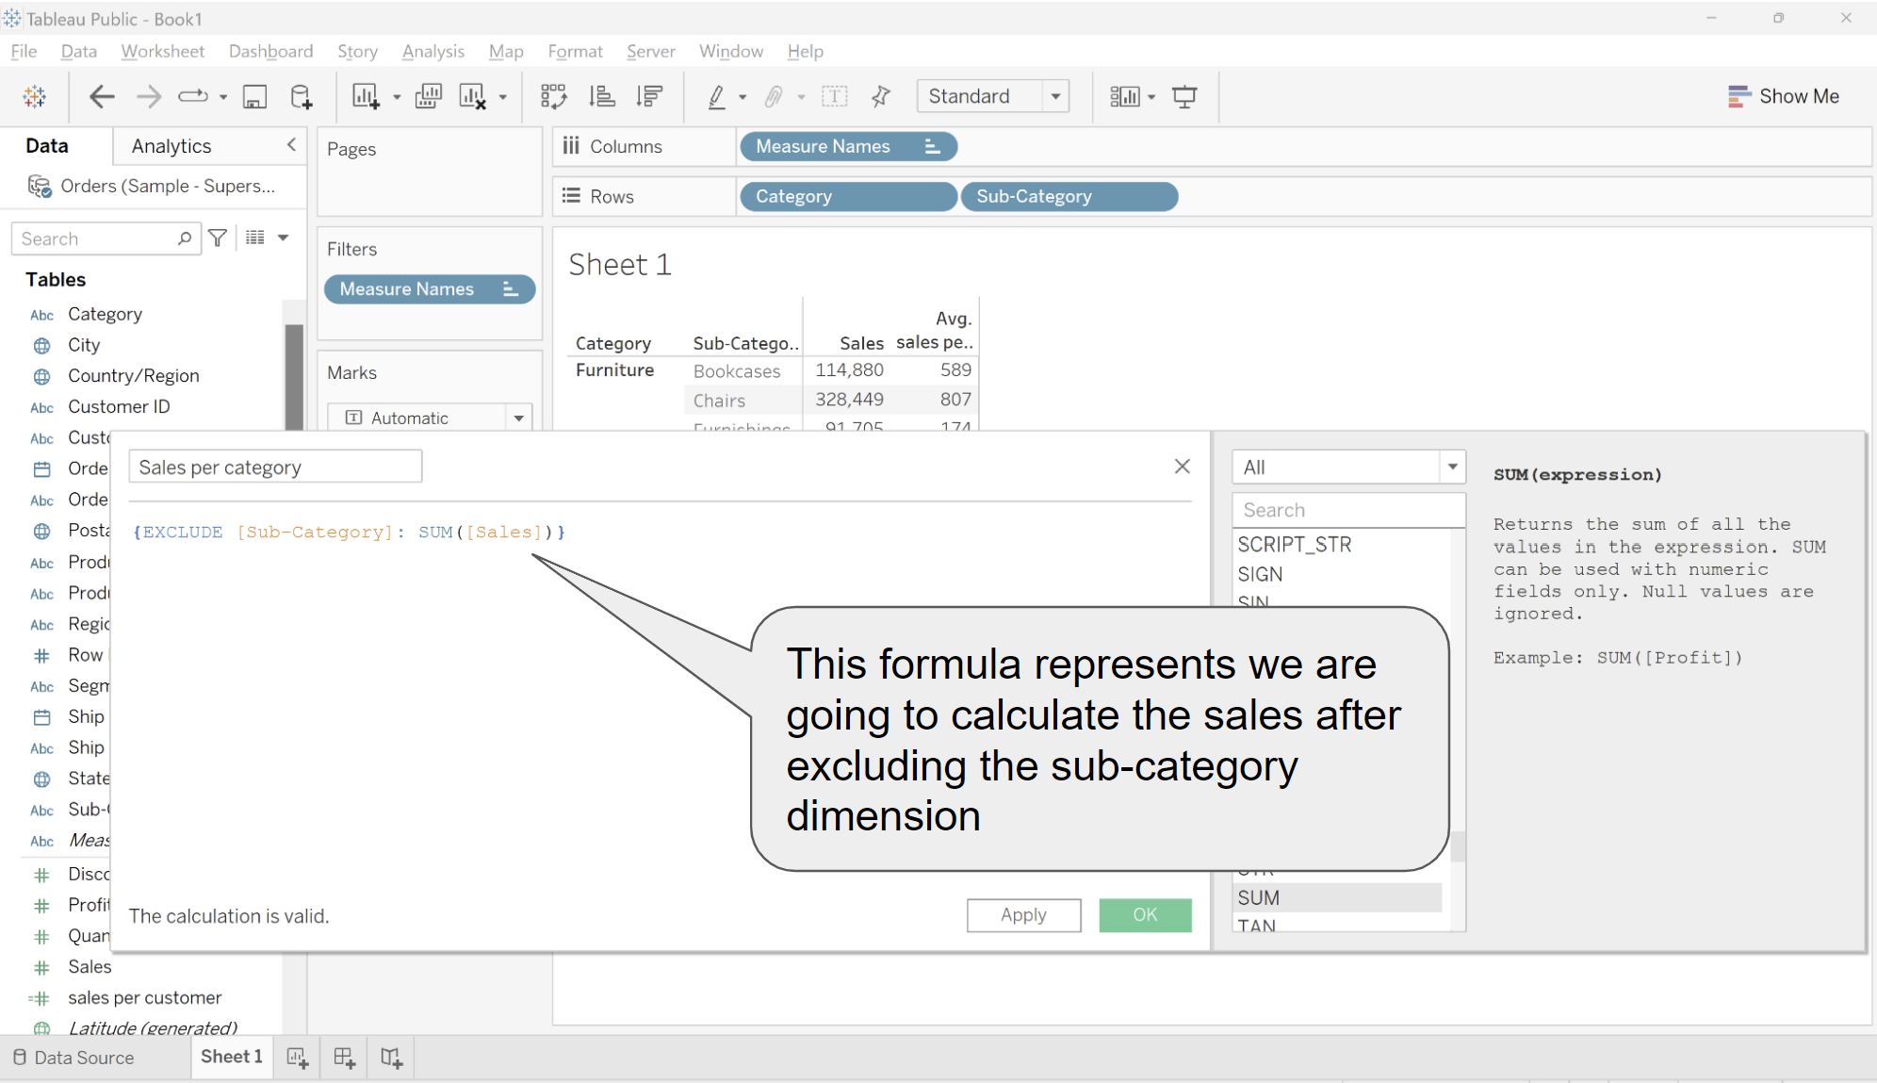

* + - Now we will divide sales per -subcategory from sales per category to get the percentage
      * We will first drag sales per category to labels

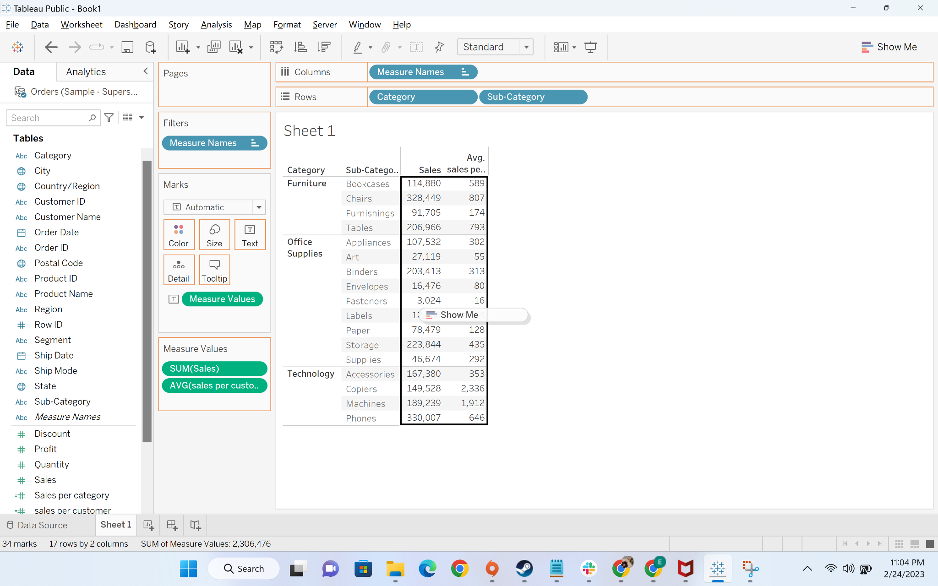

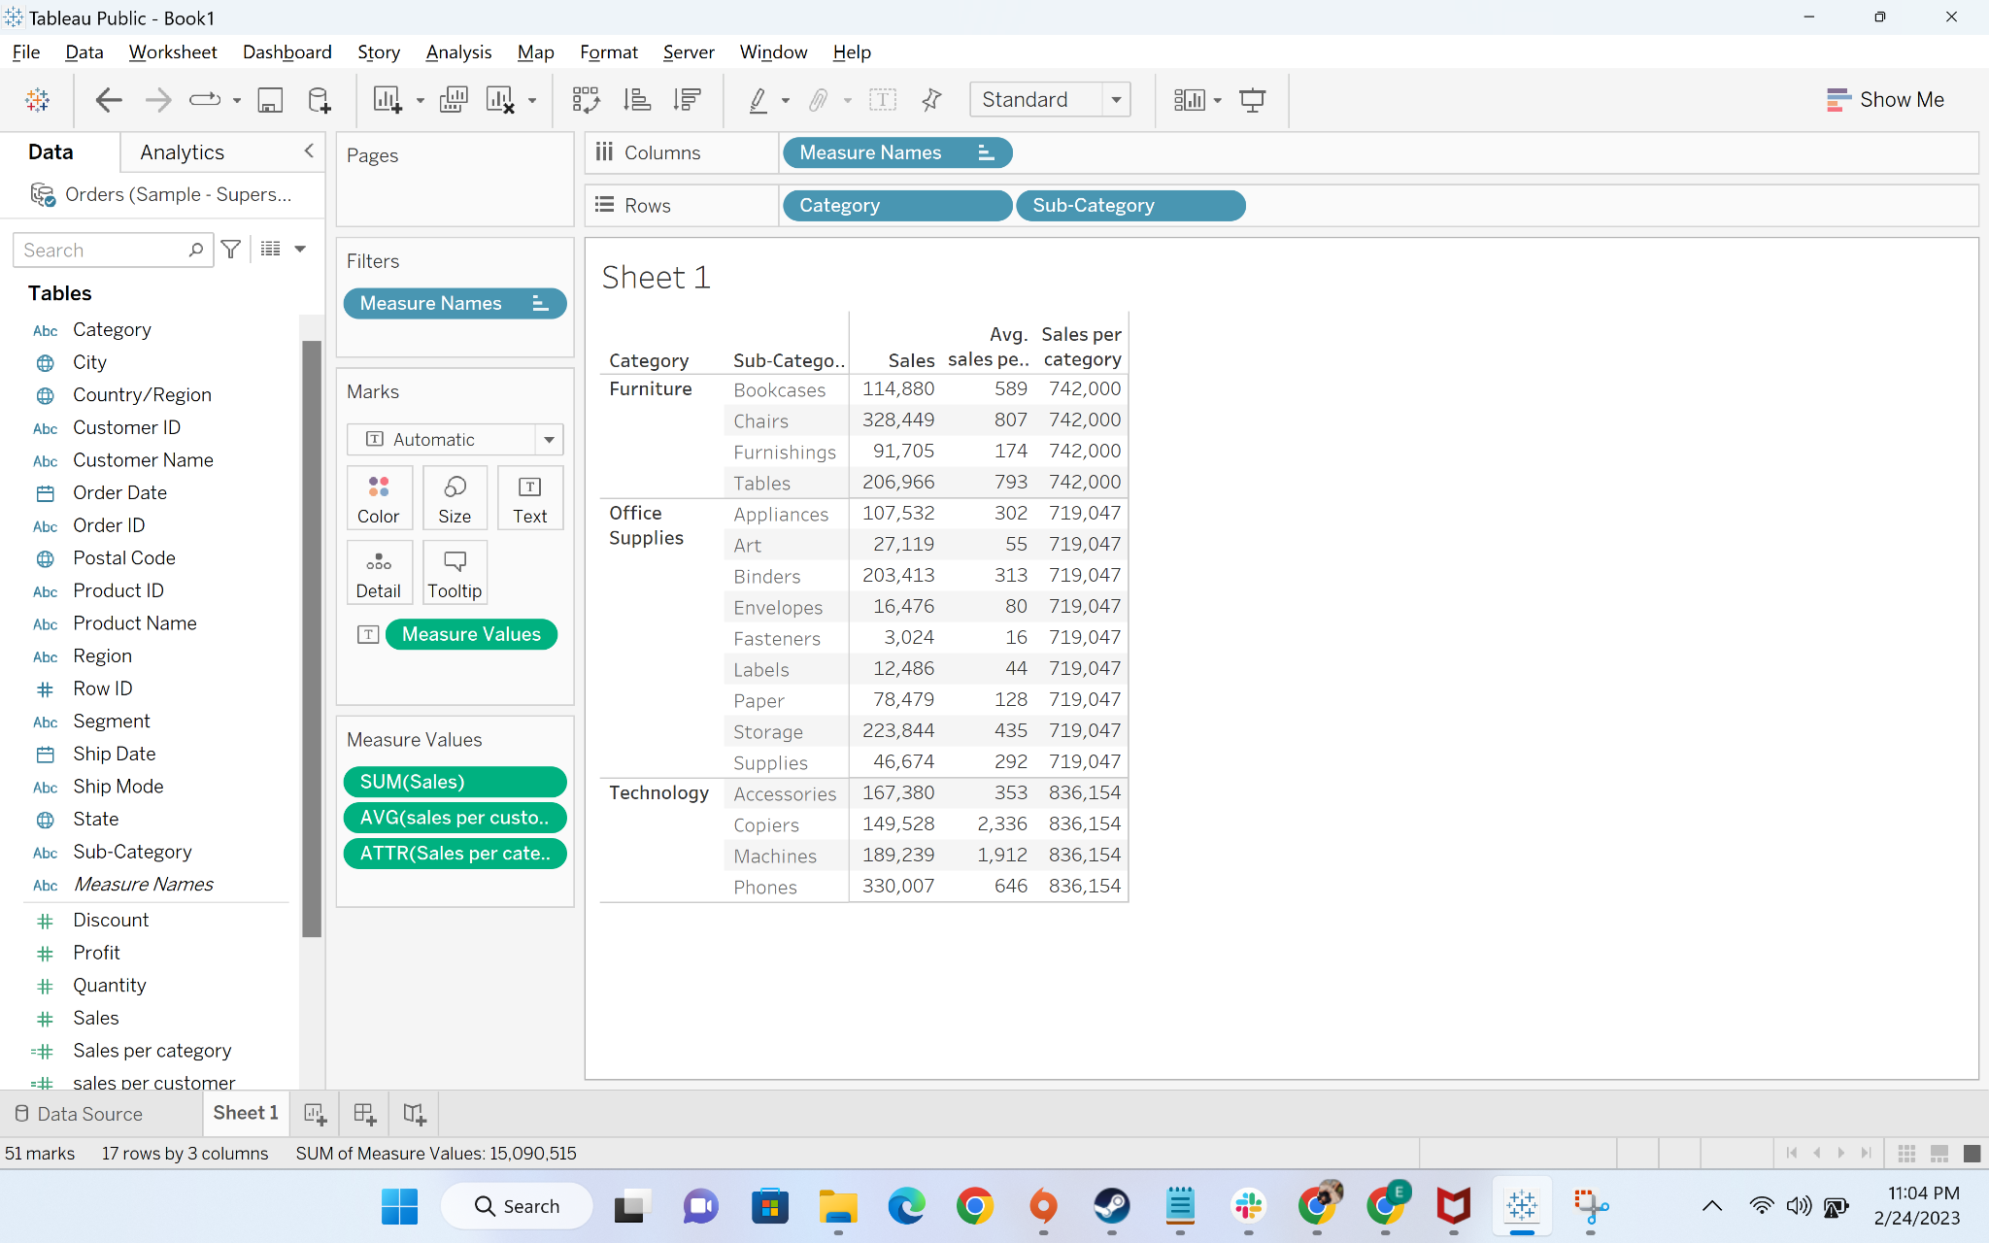

* + - * Now we will create a calculated field “pct sales per category”

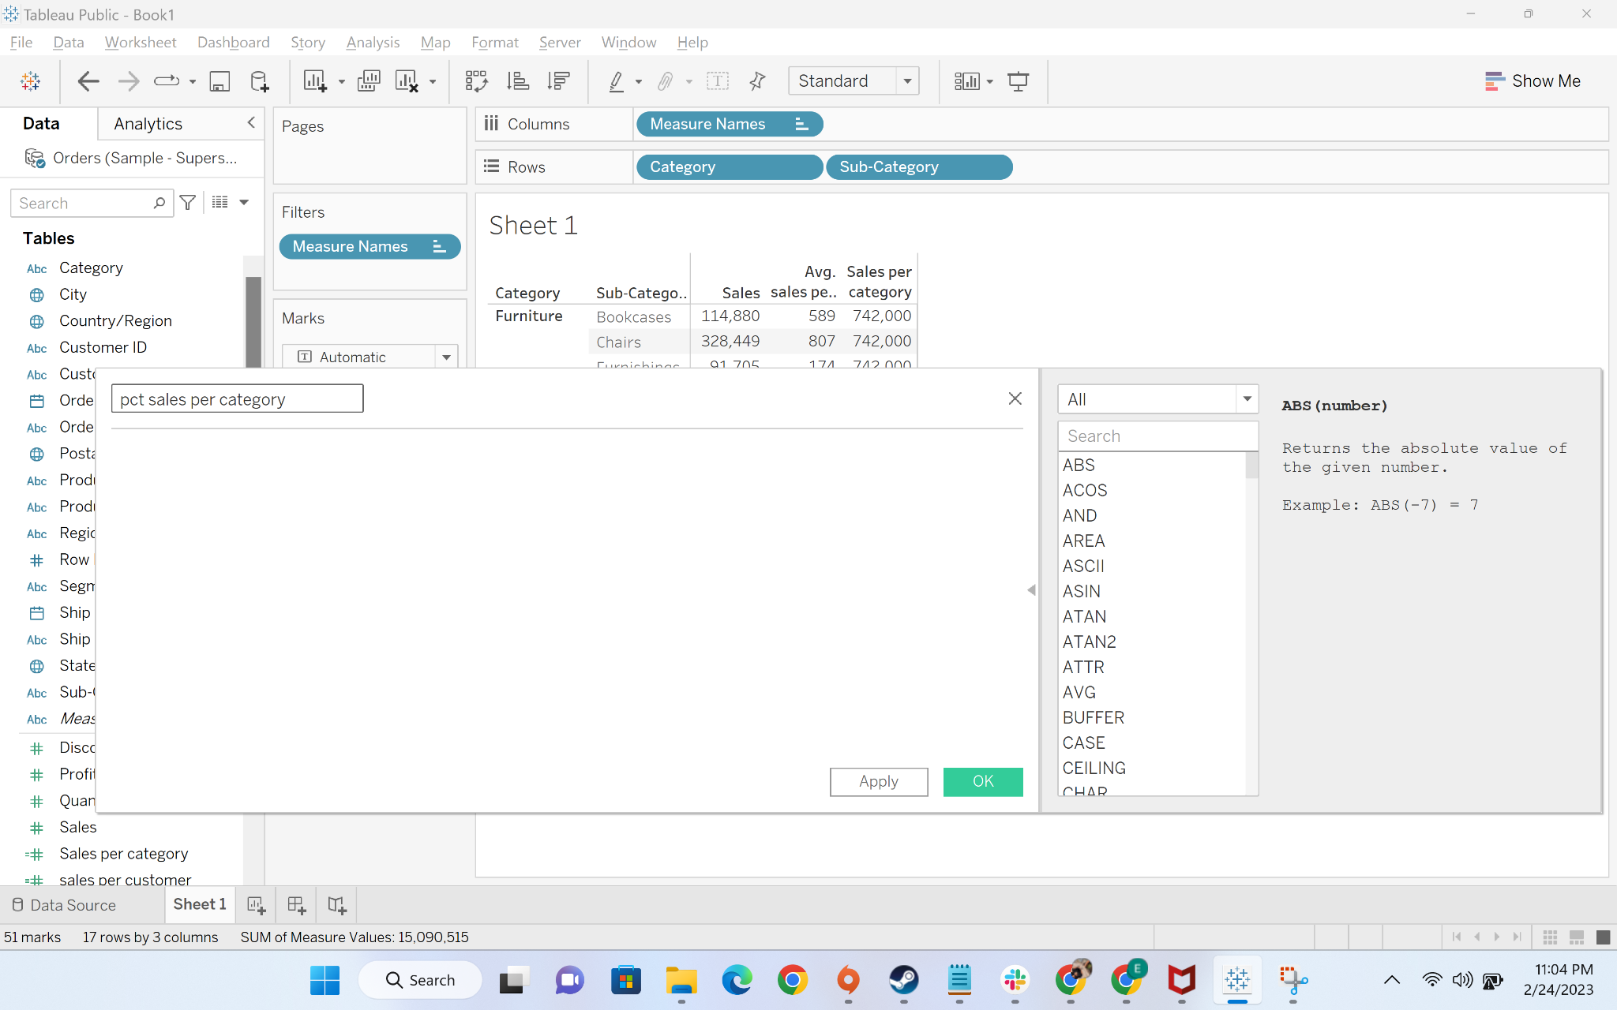

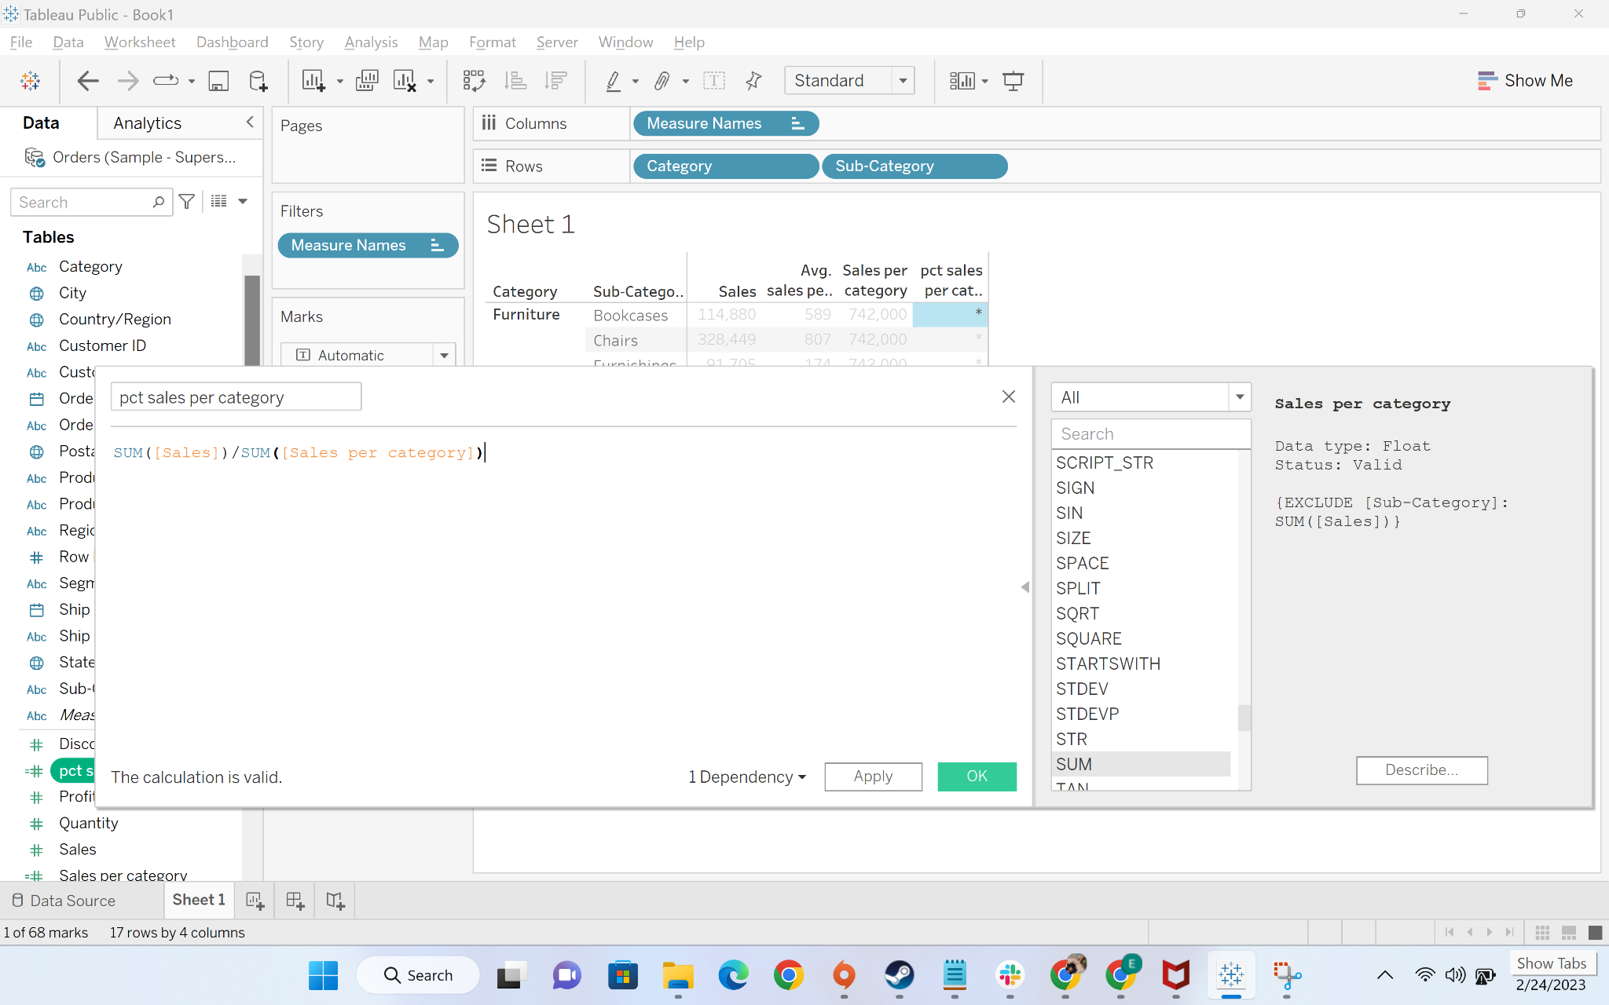

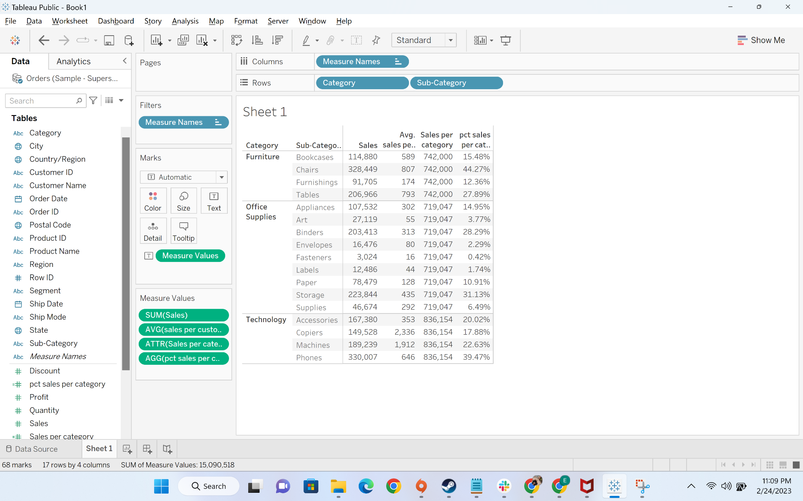

* + Now we will move to the next part of the analysis where we have to find the percentage **of sales contributed per subcategory at country level.**  This step will be divided into two parts
    - First, we will create a column to calculate sales at country level. To calculate the sales at country level, we need to calculate the sales at dimension country/region which is a fixed dimension and not part of the dimensions in view

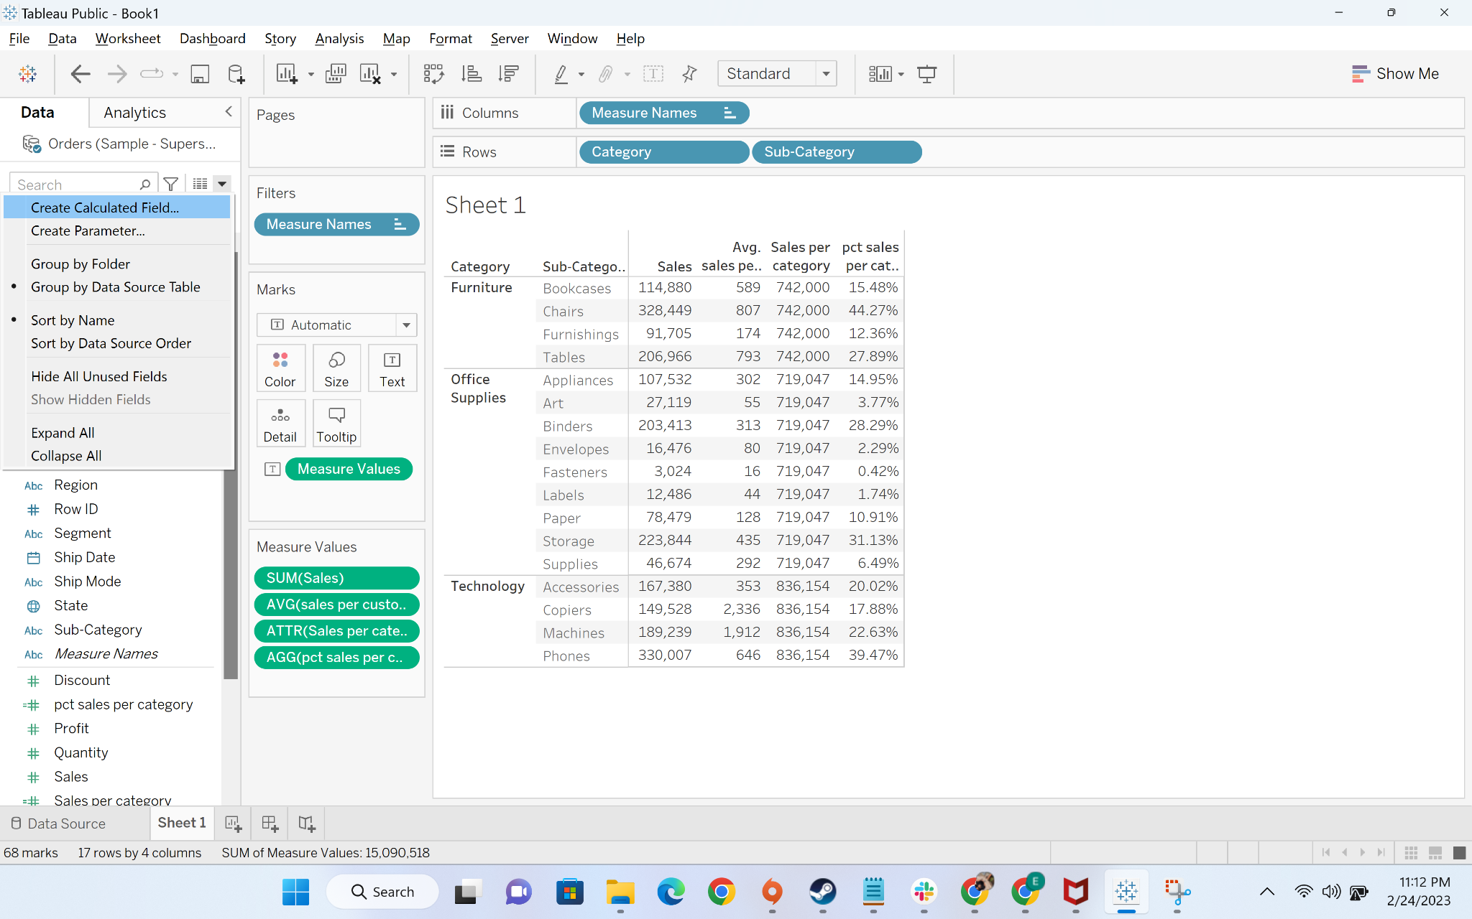

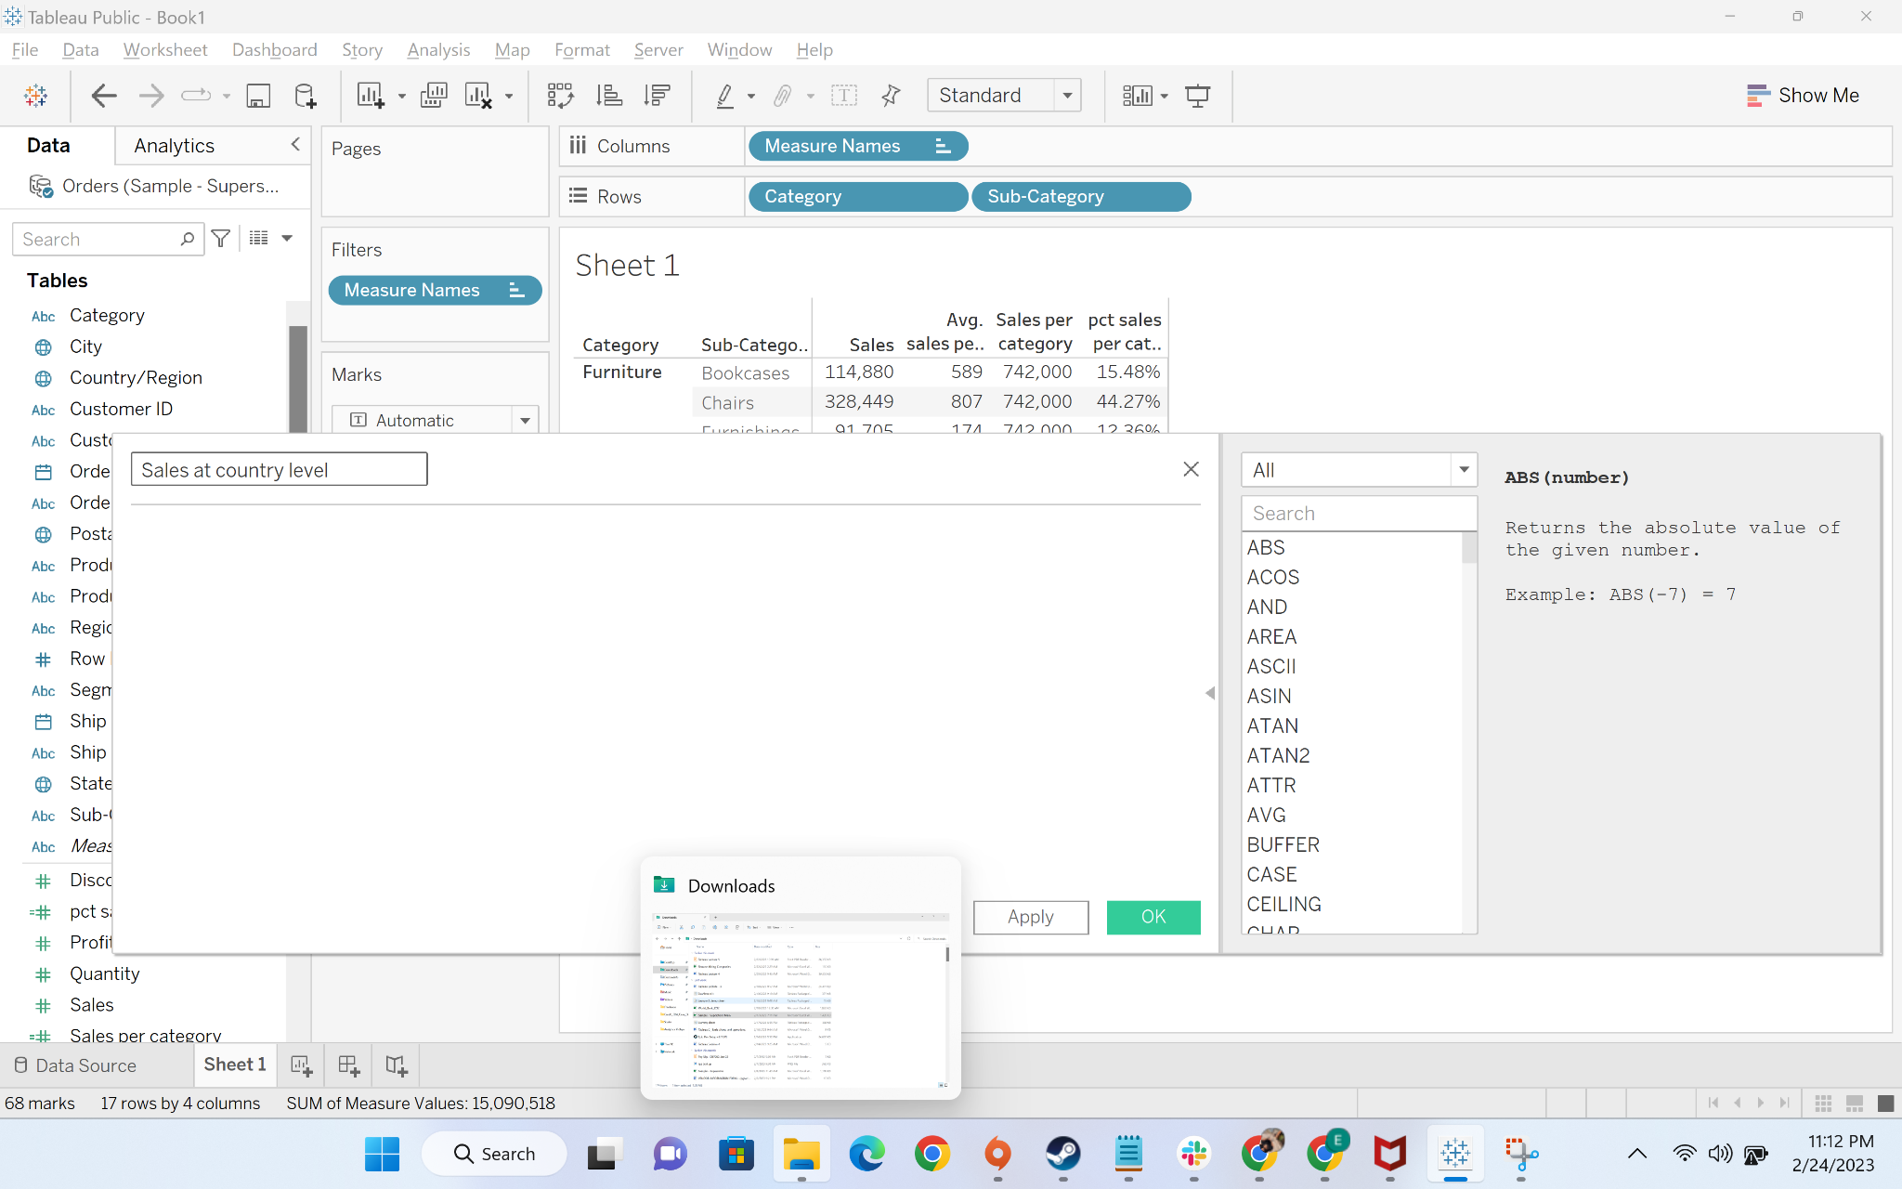

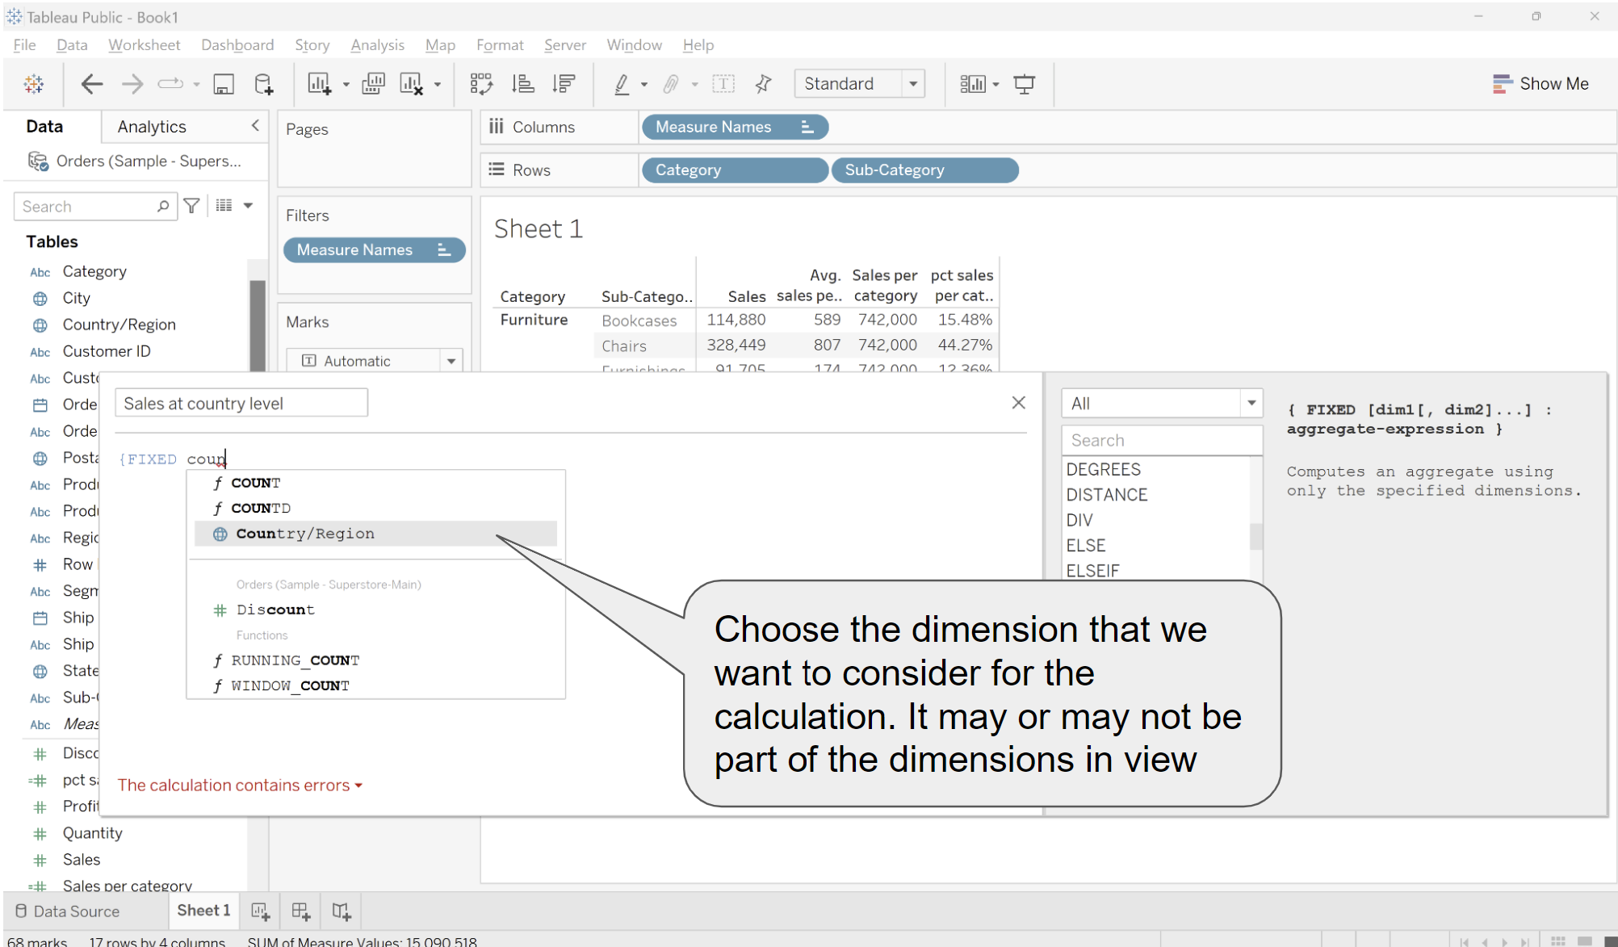

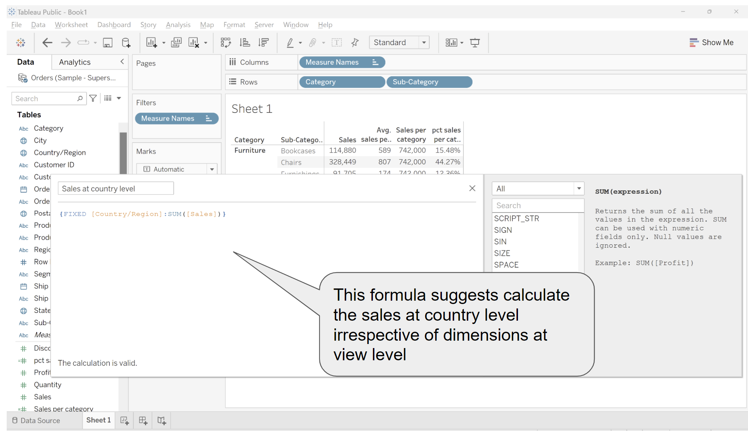

* + - Now we will divide sales per -subcategory from sales per at country level to get the percentage
      * We will first drag sales at country level to labels

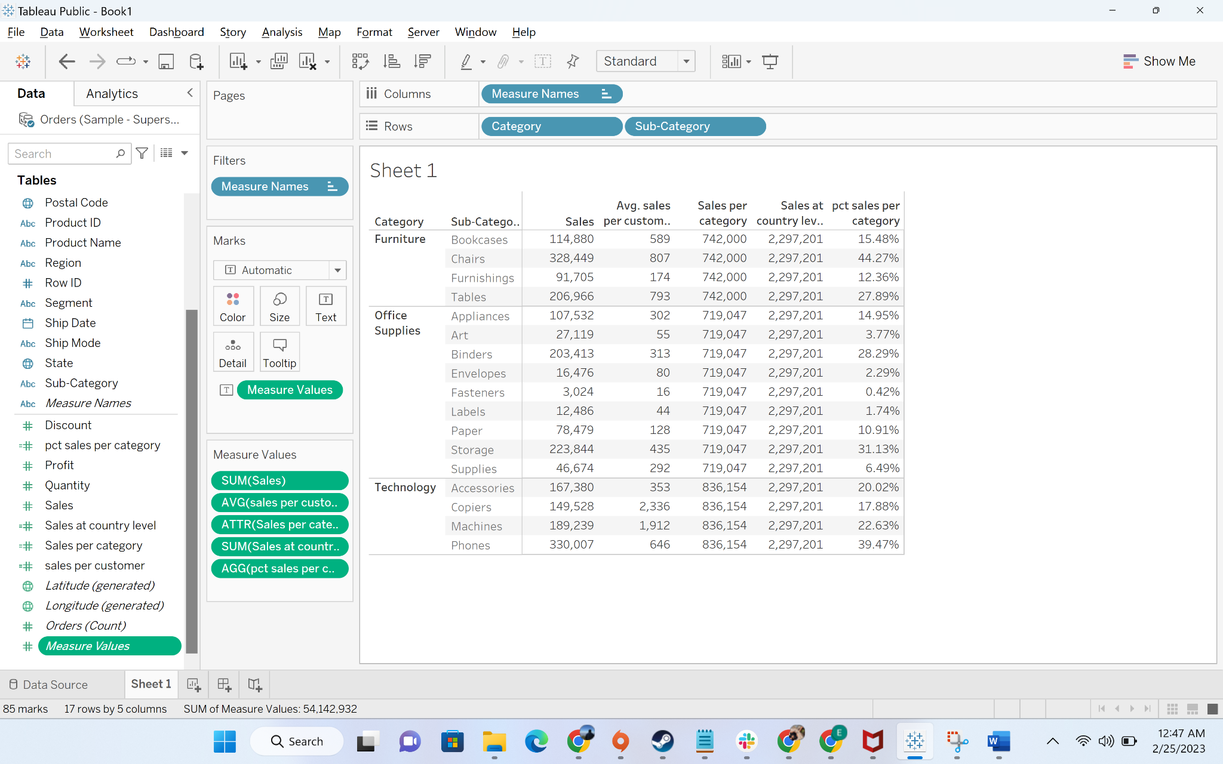

* + - * Now we will create a calculated field “pct sales at country”



 